This is the homepage of PHA Ipad, this is how it looks like:

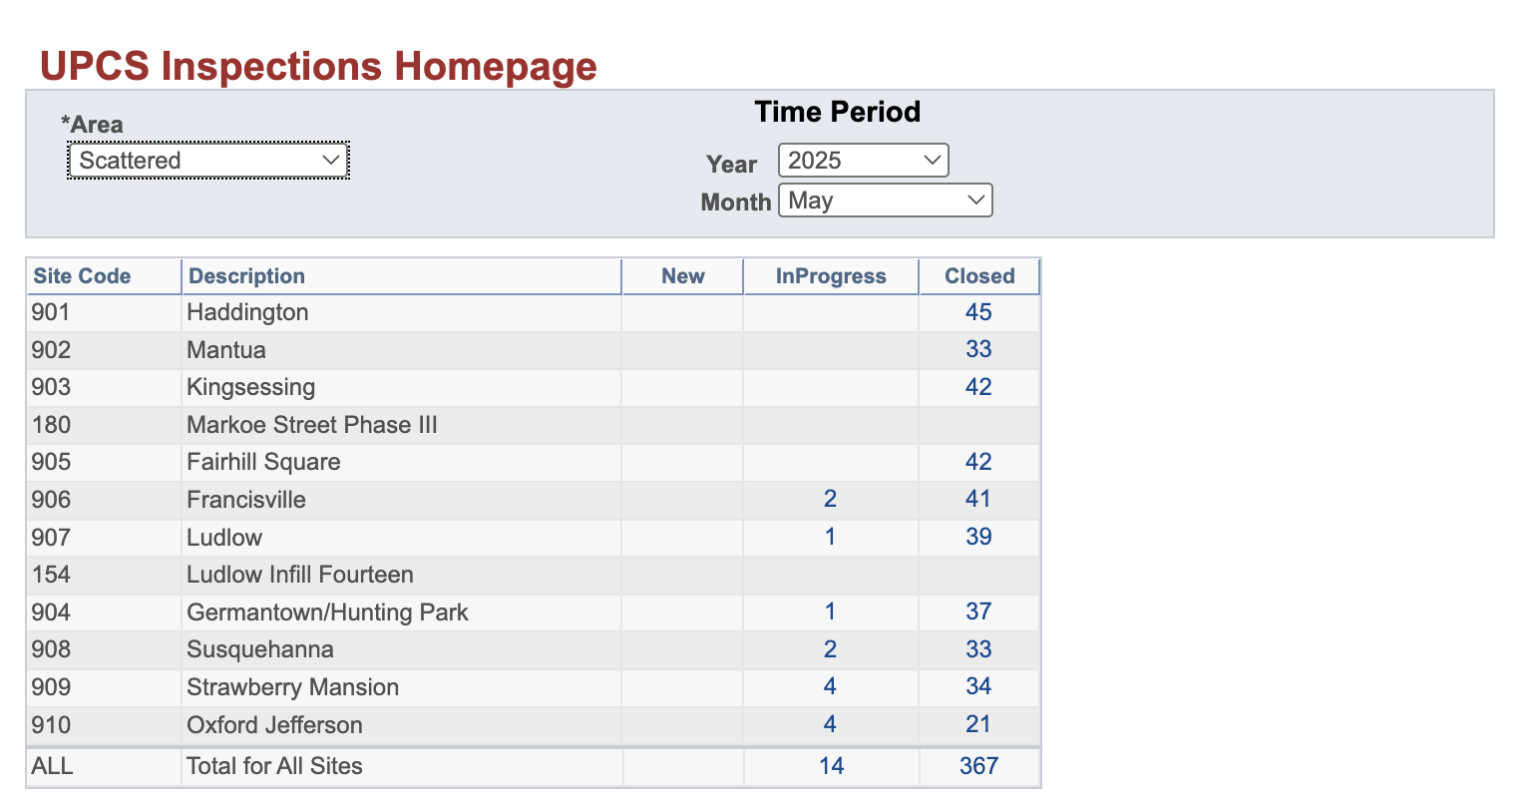

Now if you see there are 4 categories in **Area** field, which are:

1. Scattered
2. Conventional
3. AMPB
4. PAPMC

Then there is **Year** field, we have years from **2004** to **2025** (Current Year)

Then there is **Month** field, which is from Jan to Dec

After configuring that, we get the table as you can see above, which has following fields:

1. Site Code
2. Description
3. New (It means are there any new inspections added, since the month that I have selected is May Month, so it won’t have any new inspections added, if it is current month, it will have new inspections added)
4. Inprogress (It means, the inspections which are ongoing or inprogress)
5. Closed (It means, the inspections are completed)

Let’s say if I click on **Total** inspections that is 367:

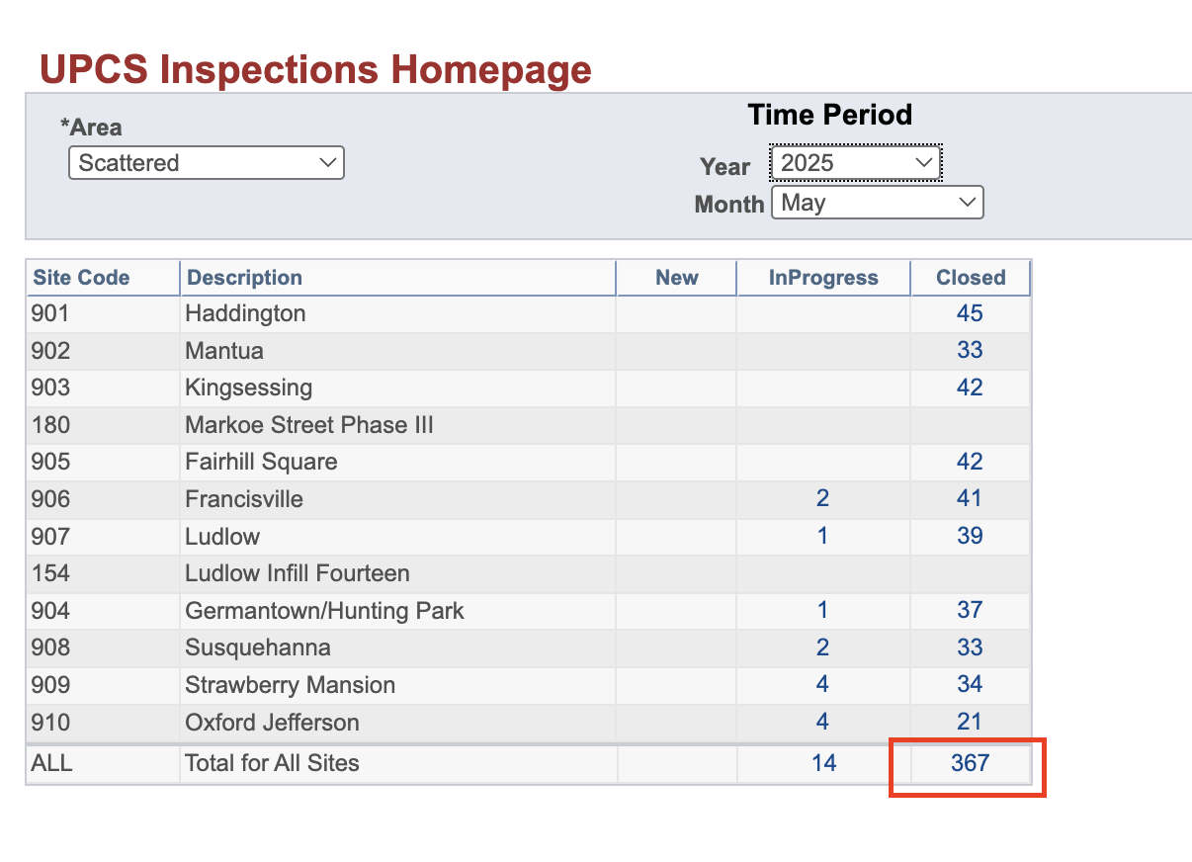

It will show you this:

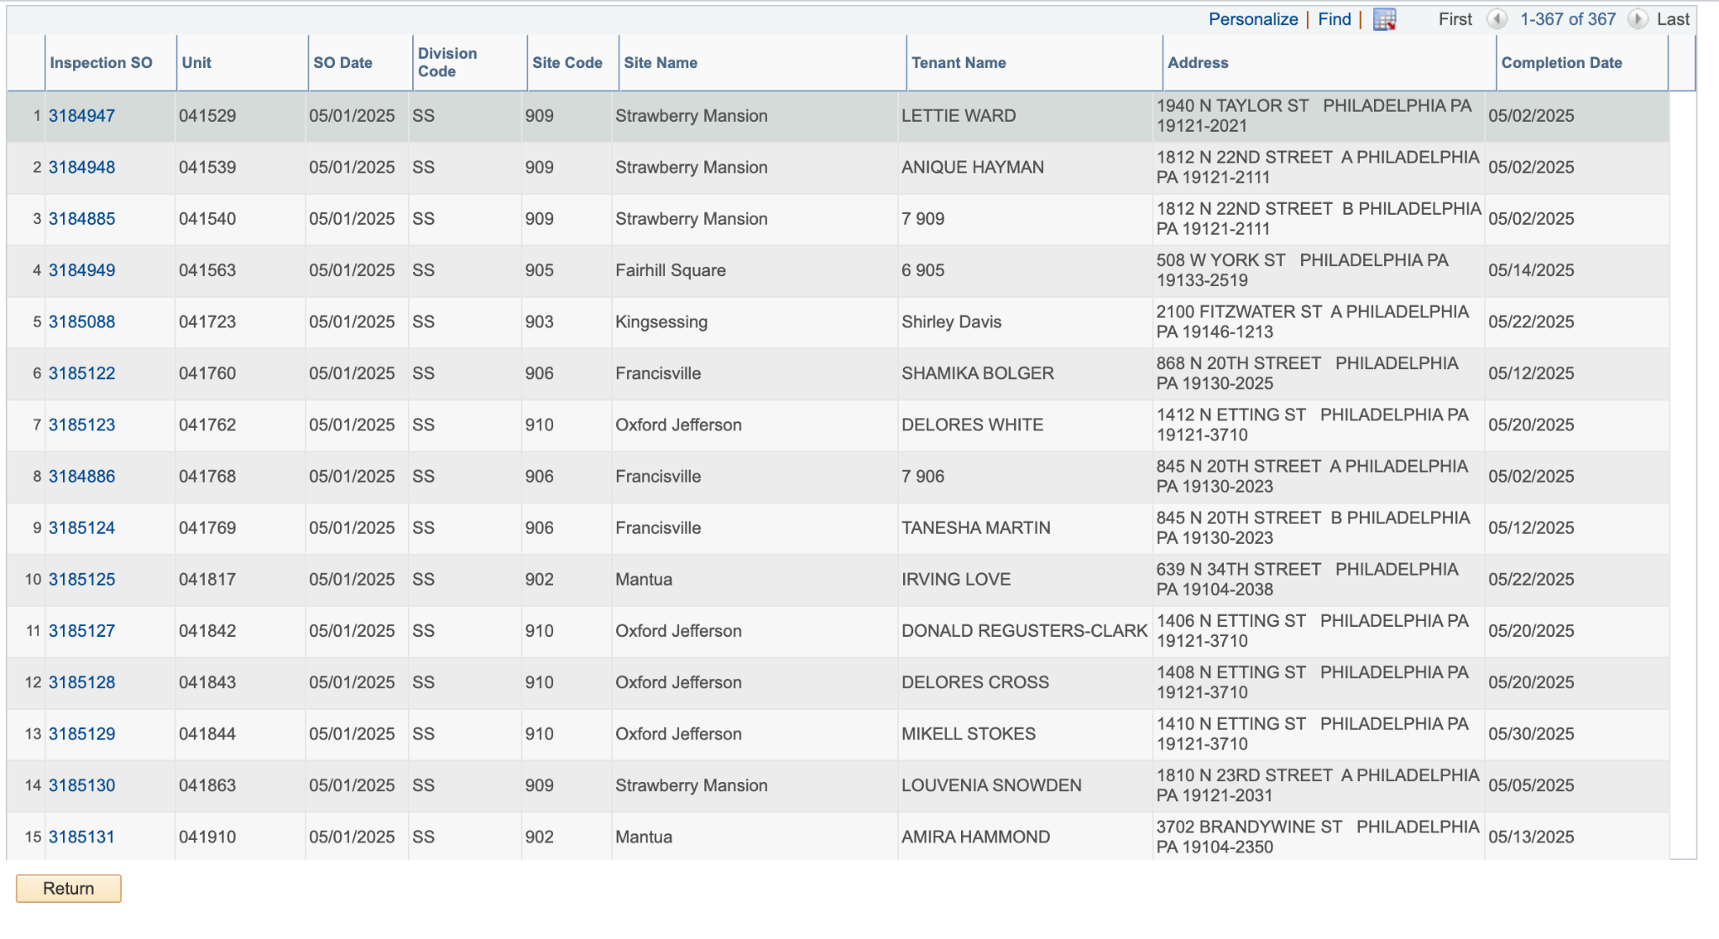

Now this has:

1. Inspection SO : This is Inspection Service Order
2. Unit
3. SO Date : This is Service Order Date
4. Division Code: This is Division Code (Like we have selected Scattered, so it is SS, similarly the division code for PAPMC is PAPMC, then for Conventional it is CS, then for AMPB, it is AMPB
5. Site Code
6. Site Name
7. Tenant Name
8. Address
9. Completion Date (This is date where inspections were completed, now if you would have clicked on Inspections which are **inprogress,** it would not have completion date)

Now when I click on specific **Inspection SO** (Inspection Service Order), let’s say the first one 3184947:

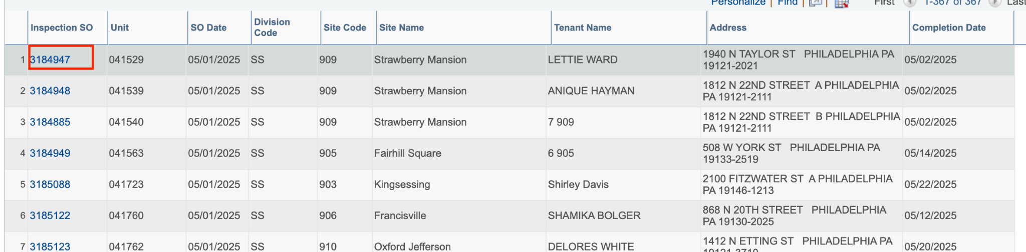

It redirects me to this page:

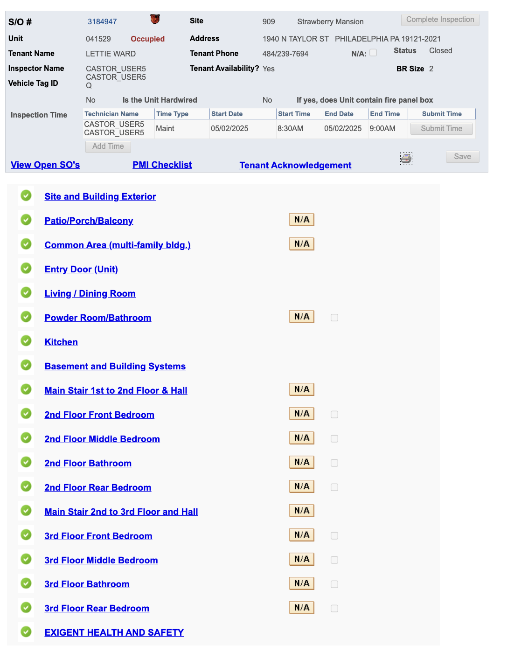

Now we have:

1. S/O # which is same as Inspection SO
2. Unit
3. Site
4. Address
5. Site Name
6. Tenant Name
7. Tenant Phone
8. Status: this has 3 fields only which are Closed, Inprogress, New
9. Inspector Name
10. Vehicle Tag ID
11. Tenant Avalability?
12. BR Size
13. Is the Unit Hardwired?
14. Inspection Time. Inspection Time has another fields, which are:
    1. Technician Name (which is same as Inspector Name)
    2. Time Type
    3. Start Date
    4. Start Time
    5. End Date
    6. End Time
    7. Submit time (it is a button, if you see it is disabled, because the inspection is already closed)
15. PMI Checklist (This is another hyperlink, which redirects to another page which shows Materials, it will be discussed below)
16. Tenant Acknowledgement(This is another hyperlink, which redirects to another page which shows further details related to this, it will be discussed below)
17. Site and Building Exterior (Another hyperlink)
18. Patio/Porch/Balcony (Another hyperlink)
19. Common Area (multi-family bldg.) (Another hyperlink)
20. Entry Door (Unit) (Another hyperlink)
21. Living / Dining Room (Another hyperlink)
22. Powder Room/Bathroom (Another hyperlink)
23. Kitchen (Another hyperlink)
24. Basement and Building Systems (Another hyperlink)
25. Main Stair 1st to 2nd Floor & Hall (Another hyperlink)
26. 2nd Floor Front Bedroom (Another hyperlink)
27. 2nd Floor Middle Bedroom (Another hyperlink)
28. 2nd Floor Bathroom (Another hyperlink)
29. 2nd Floor Rear Bedroom (Another hyperlink)
30. Main Stair 2nd to 3rd Floor and Hall (Another hyperlink)
31. 3rd Floor Front Bedroom (Another hyperlink)
32. 3rd Floor Middle Bedroom (Another hyperlink)
33. 3rd Floor Bathroom (Another hyperlink)
34. 3rd Floor Rear Bedroom (Another hyperlink)
35. EXIGENT HEALTH AND SAFETY (Another hyperlink)

At the bottom, it has **Attach Images** for the inspection

#### **PMI Checklist**

Now if you click on PMI Checklist, this is what it shows:

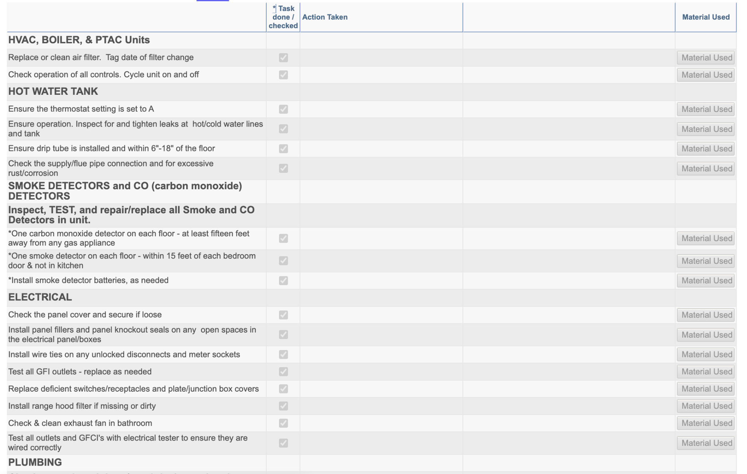

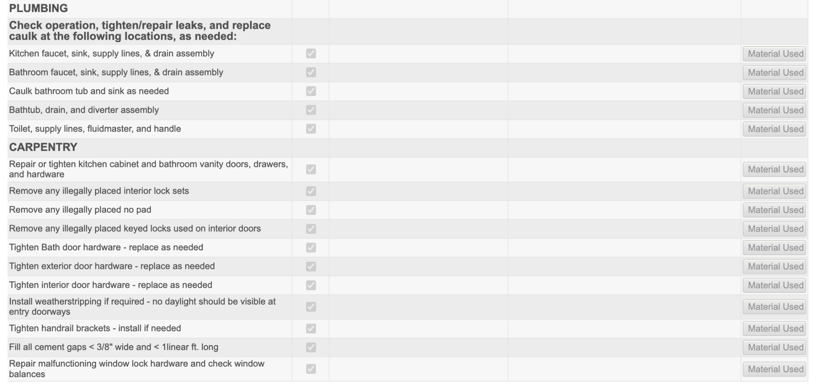

#### 

#### **Tenant Acknowledgement**

#### Coming back to the screen where it shows details for that **Inspection SO**

#### Now, if you click on Tenant Acknowledgement, this is what it shows:

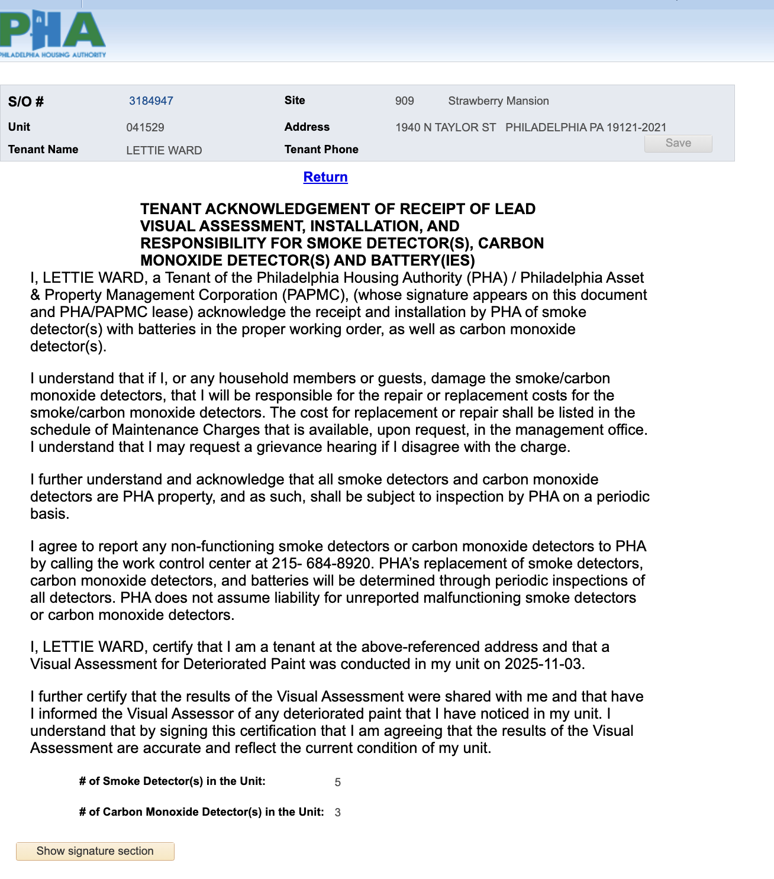

Now when you click on **Show signature section**:

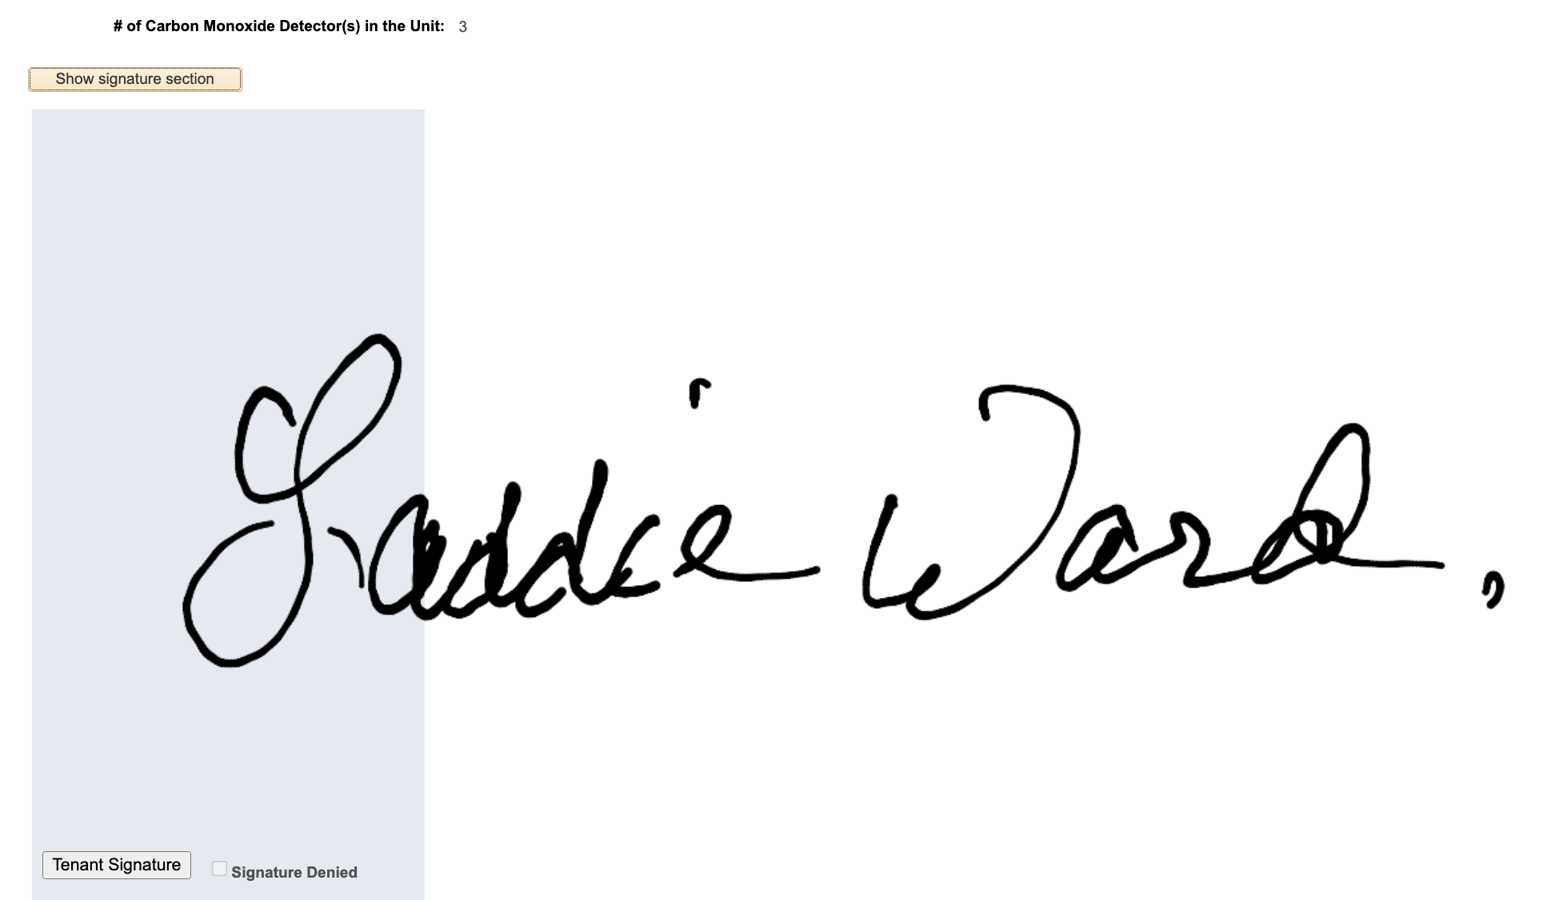

#### **View Open SO**

This is section where there are any outstanding previous **Service Orders**, now for this unit, there are no open Service Orders, it looks like this:

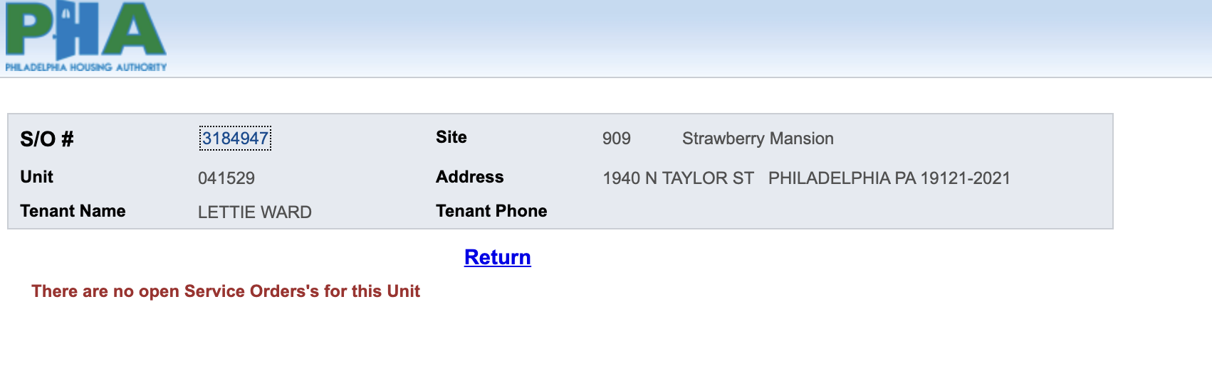

Let’s say if the scenario was there were any **Open Service Orders**, then it would look like this:

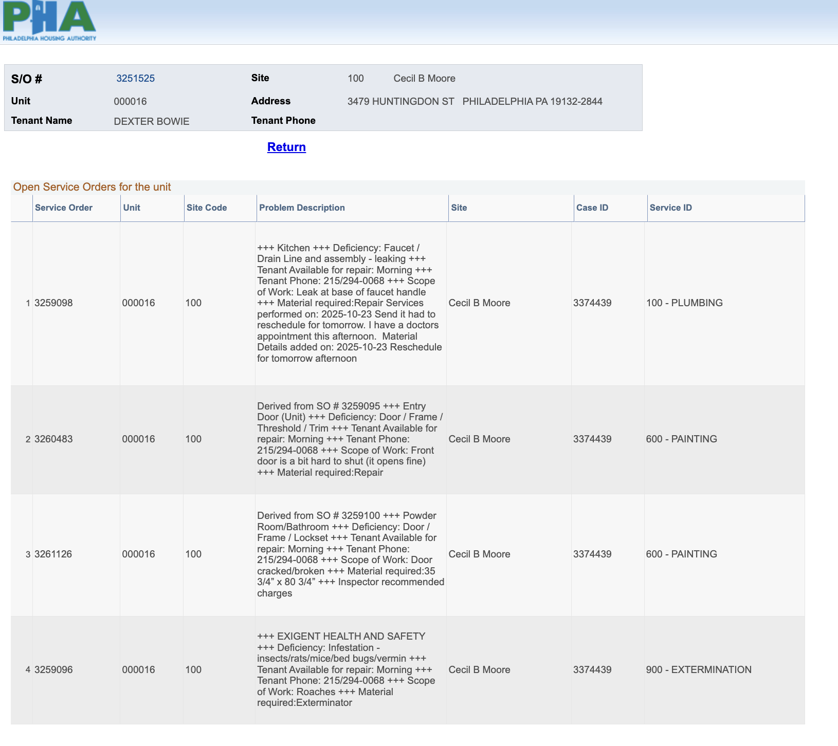

#### 

#### **Site and Building Exterior**

#### Coming back to the screen where it shows details for that **Inspection SO**

Now, if you click on Site and Building Exterior, this is what it shows:

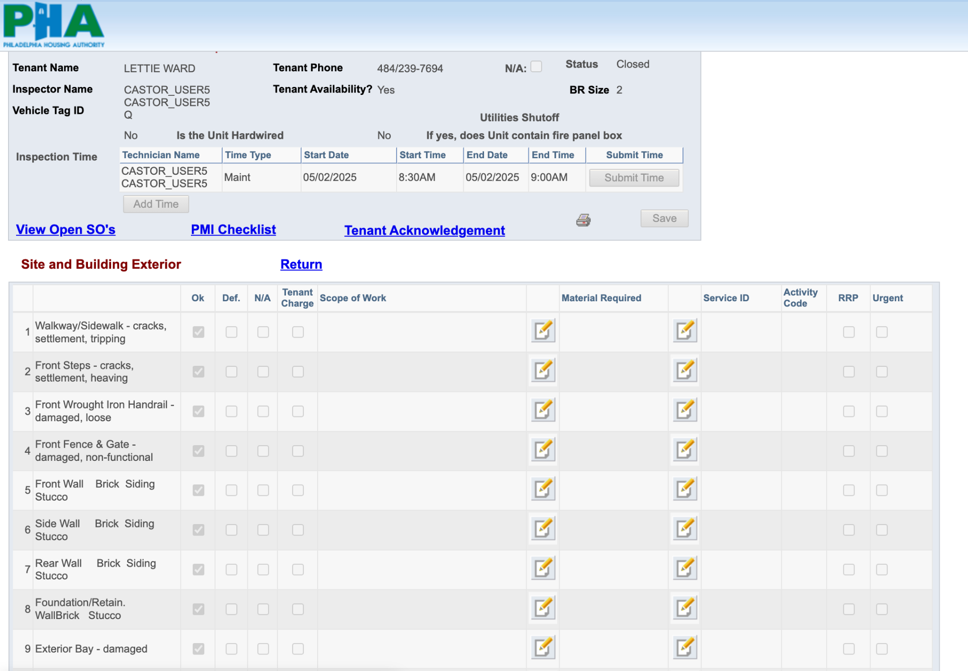

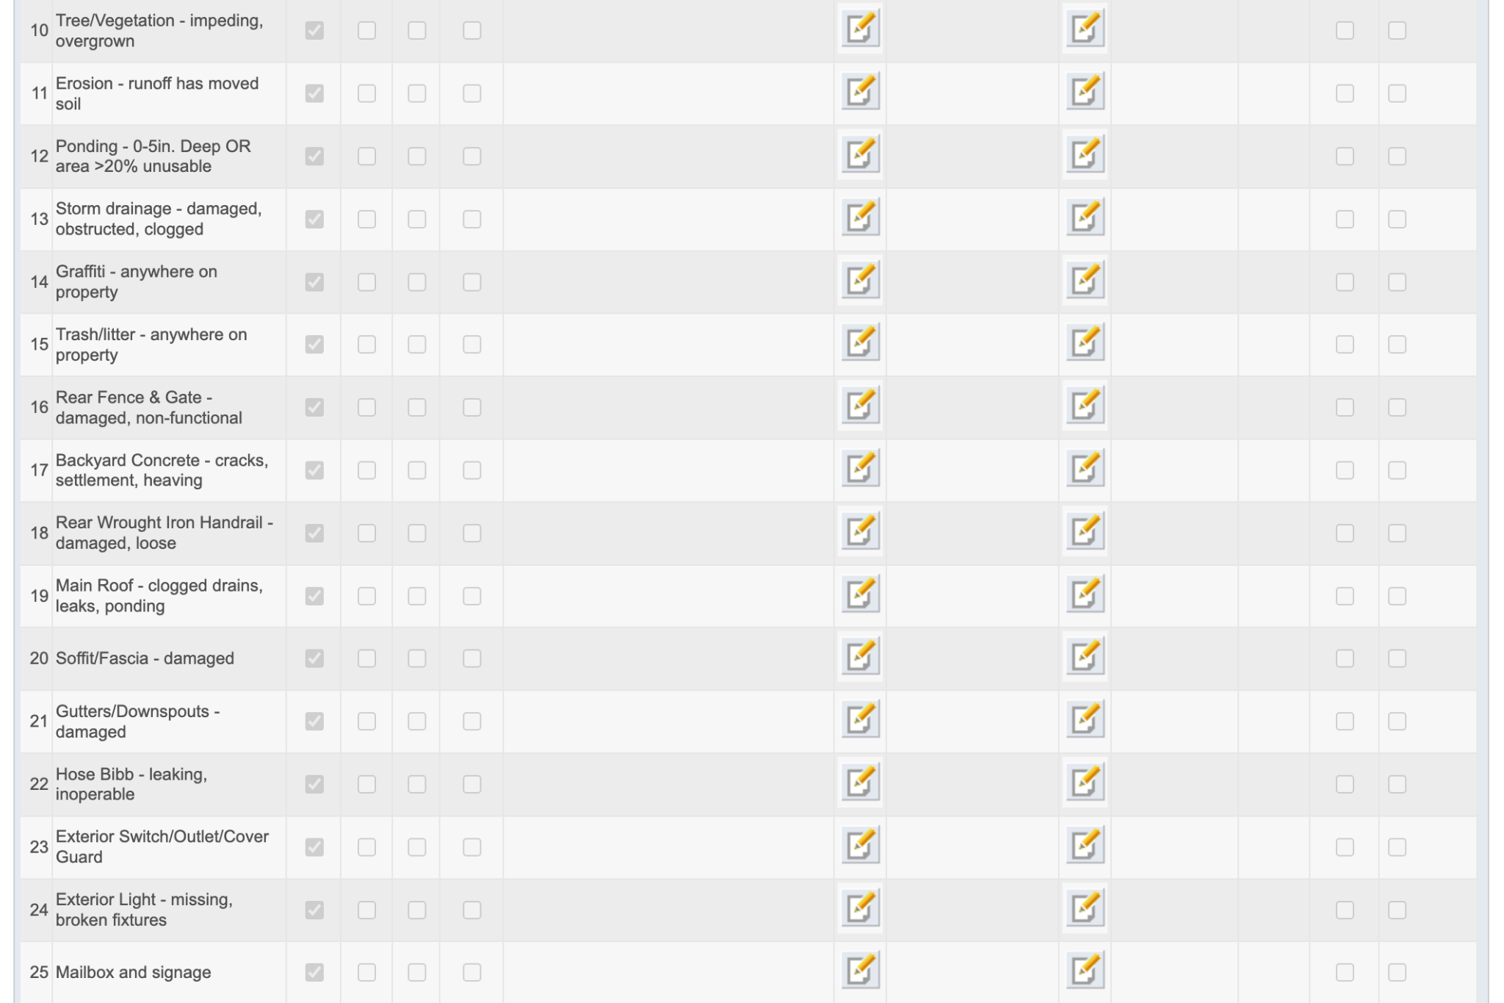

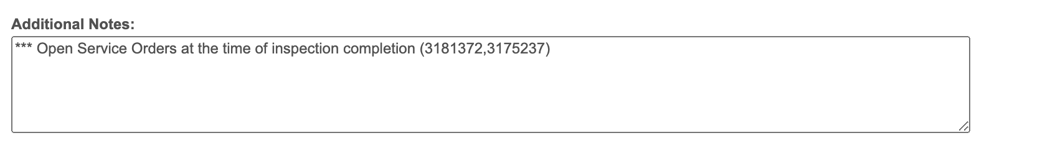

Now if you notice the columns for this, there are fields:

1. OK ⇒ it means if everything is fine, the inspector clicks OK (no problem with the inspection of the Unit)
2. NA ⇒ it means Not Applicable, if you get to the unit (for example there is no Back Door in the unit) so the inspector has to click Not Applicable.
3. Def ⇒ Let’s say if the inspector finds if there is no smoke detector (smoke detector is an example over here), then the inspector needs to select **Def** meaning **Defiency** because as per the law, it needs to have Smoke Detector in the US, so the inspector has to also write **Scope of Work** that the owner has to work or repair for the house
4. Scope of Work ⇒ As explained above in 3rd field, when there is **Def**, the inspector has to define the **Scope of Work** section otherwise leave it empty if it looks good
5. Material Required ⇒ It is material required by the owner to repair for that particular part
6. **RRP** ⇒ Recently PHA has removed RRP button for **Lead Paints only**, it is used if it is Lead free or not
7. Tenant Charge ⇒ If the tenant has damaged the room or part where it was inspected, the inspector will click on Tenant Charge. The money needs to be paid by the Tenant and not by the Owner. Let’s say if the Tenant refuse it, if you look above we had **Tenant Acknowledgement**, it will deny the acknowledgement from PHA
8. Urgent ⇒ When the inspector selects Urgent, then it will show PHA needs to treat the problem immediately. When you scroll down to **EHS Section** (it is Exigent Health Safety), usually the inspectors need to be called on the phone call and has to be fixed by 24 hrs or duration defined by **NSPIRE** governed by HUD (Housing Urban Development)

#### 

#### **Patio/Porch/Balcony**

#### Coming back to the screen where it shows details for that **Inspection SO**

Now, if you click on Patio/Porch/Balcony, this is what it shows:

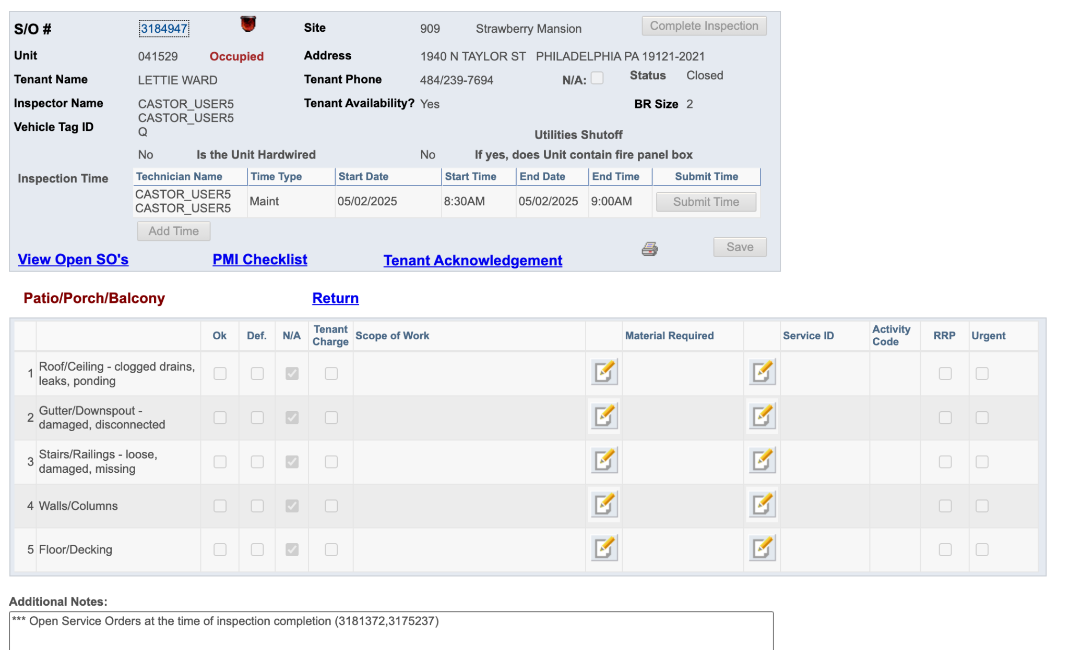

**Common Area (multi-family bldg.)**

#### Coming back to the screen where it shows details for that **Inspection SO**

Now, if you click on Common Area (multi-family bldg) , this is what it shows:

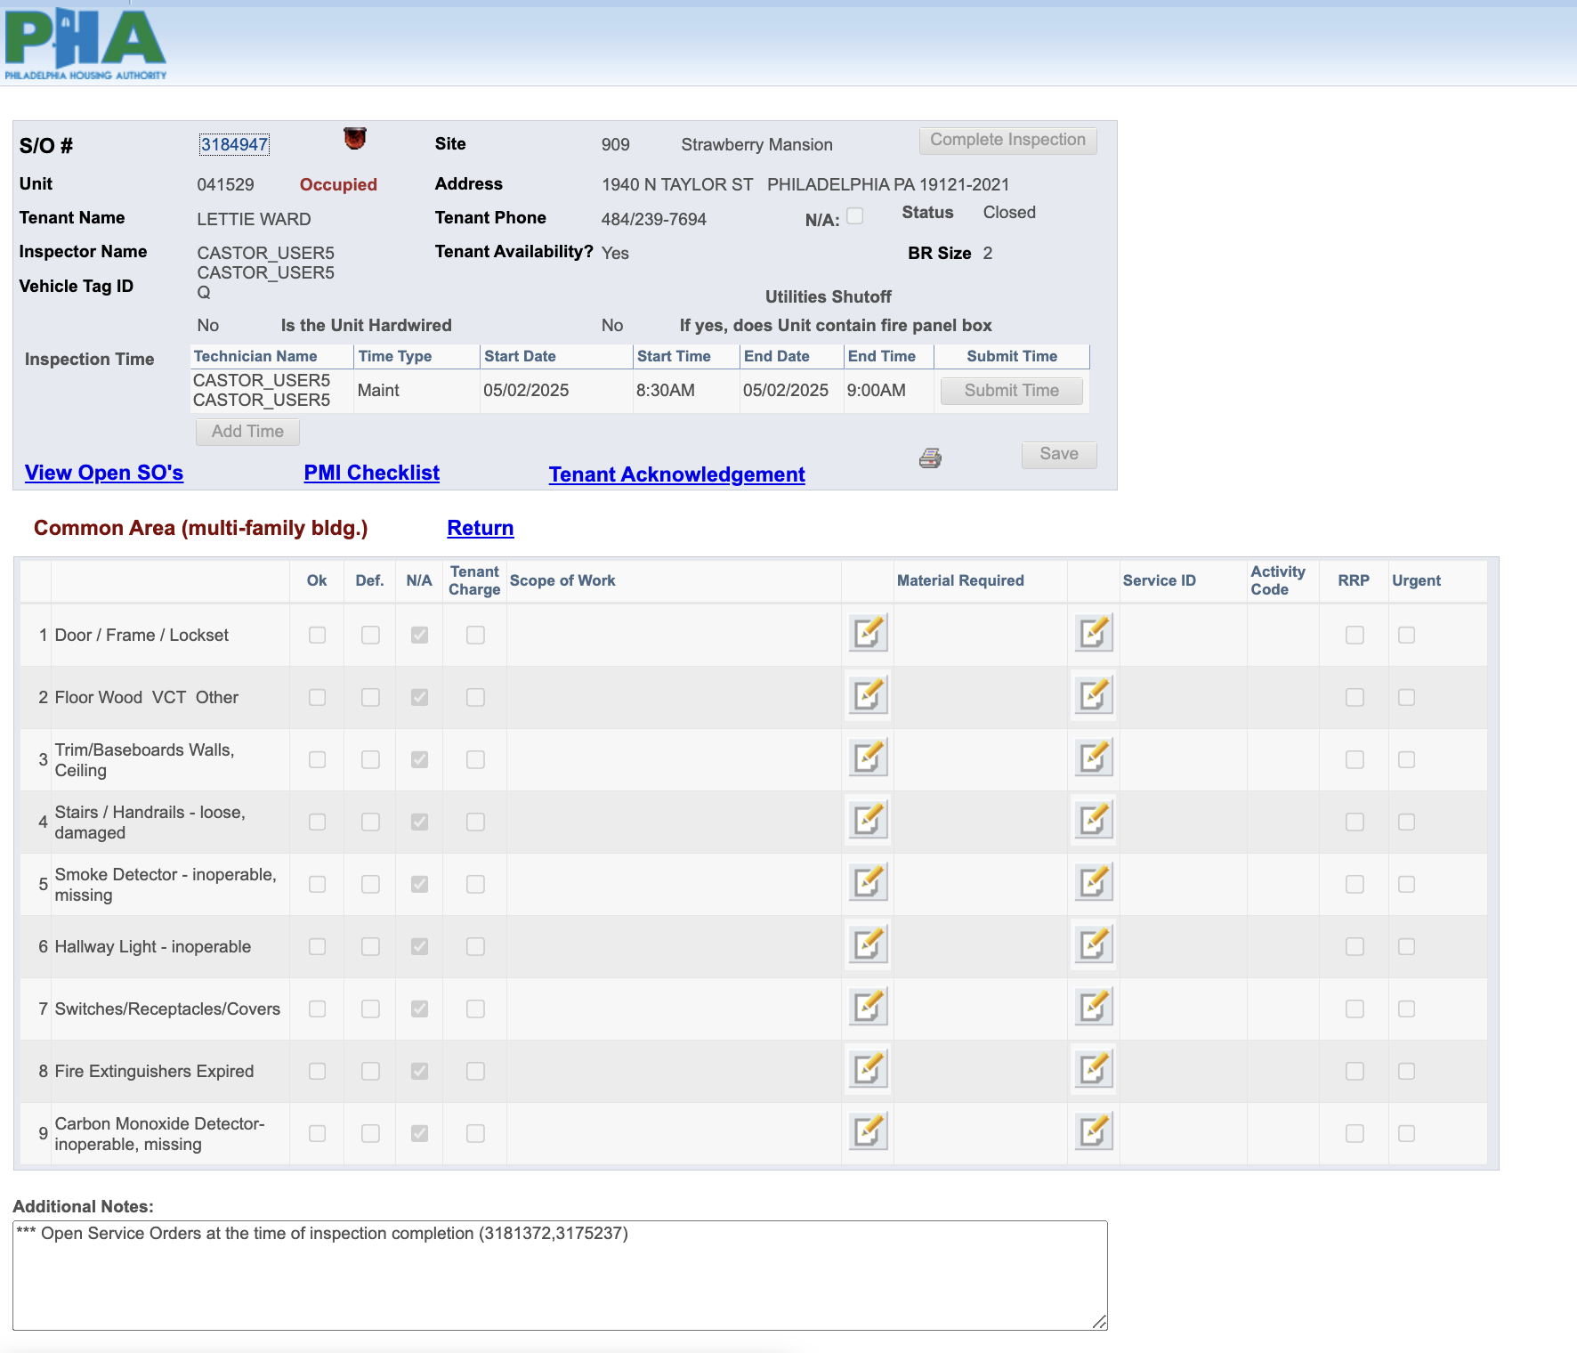

**Entry Door (Unit)**

#### Coming back to the screen where it shows details for that **Inspection SO**

Now, if you click on Entry Door (Unit), this is what it shows:

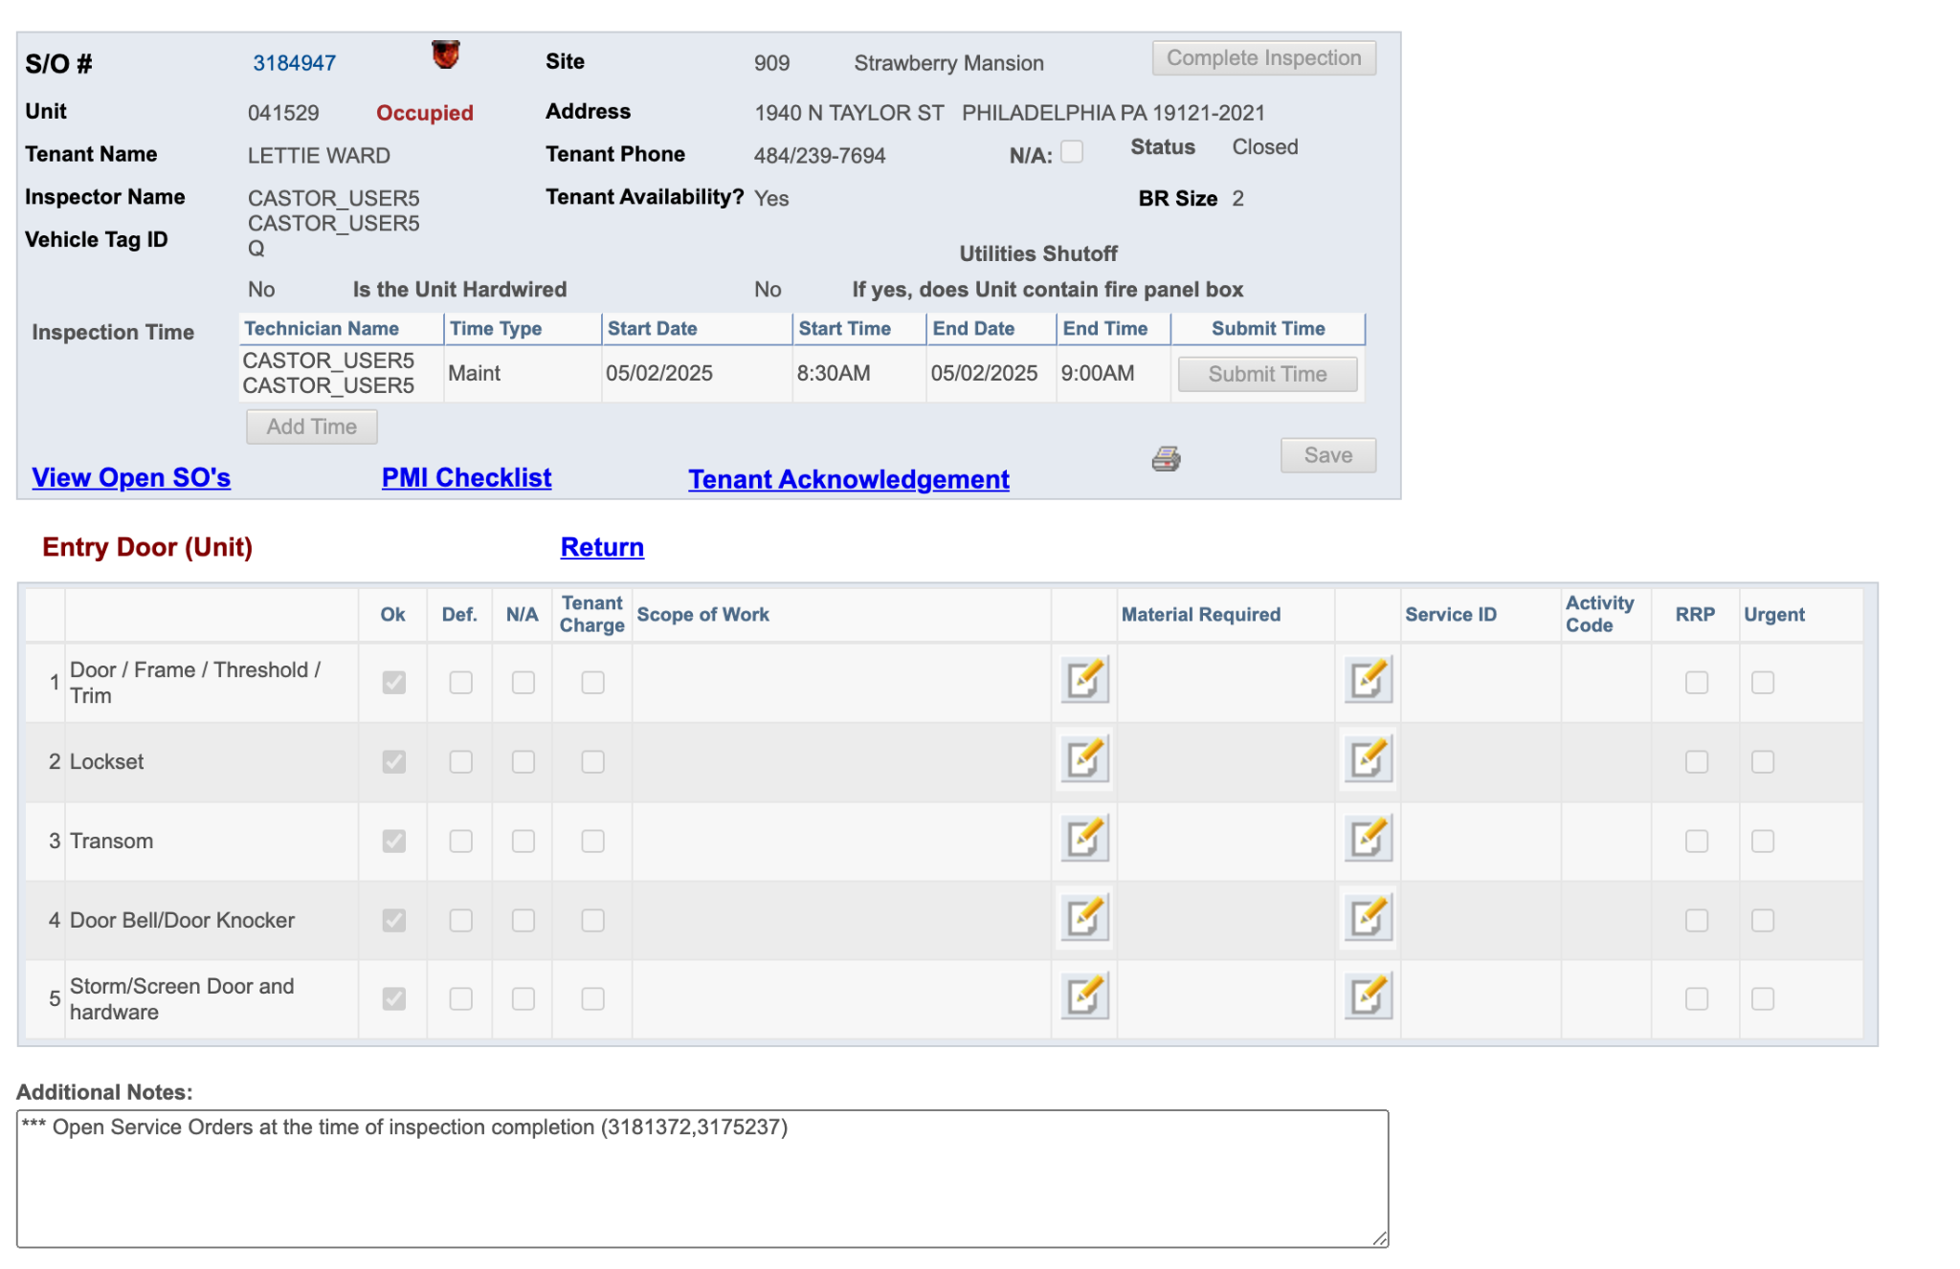

**Living / Dining Room**

#### Coming back to the screen where it shows details for that **Inspection SO**

Now, if you click on Living/ Dining Room, this is what it shows:

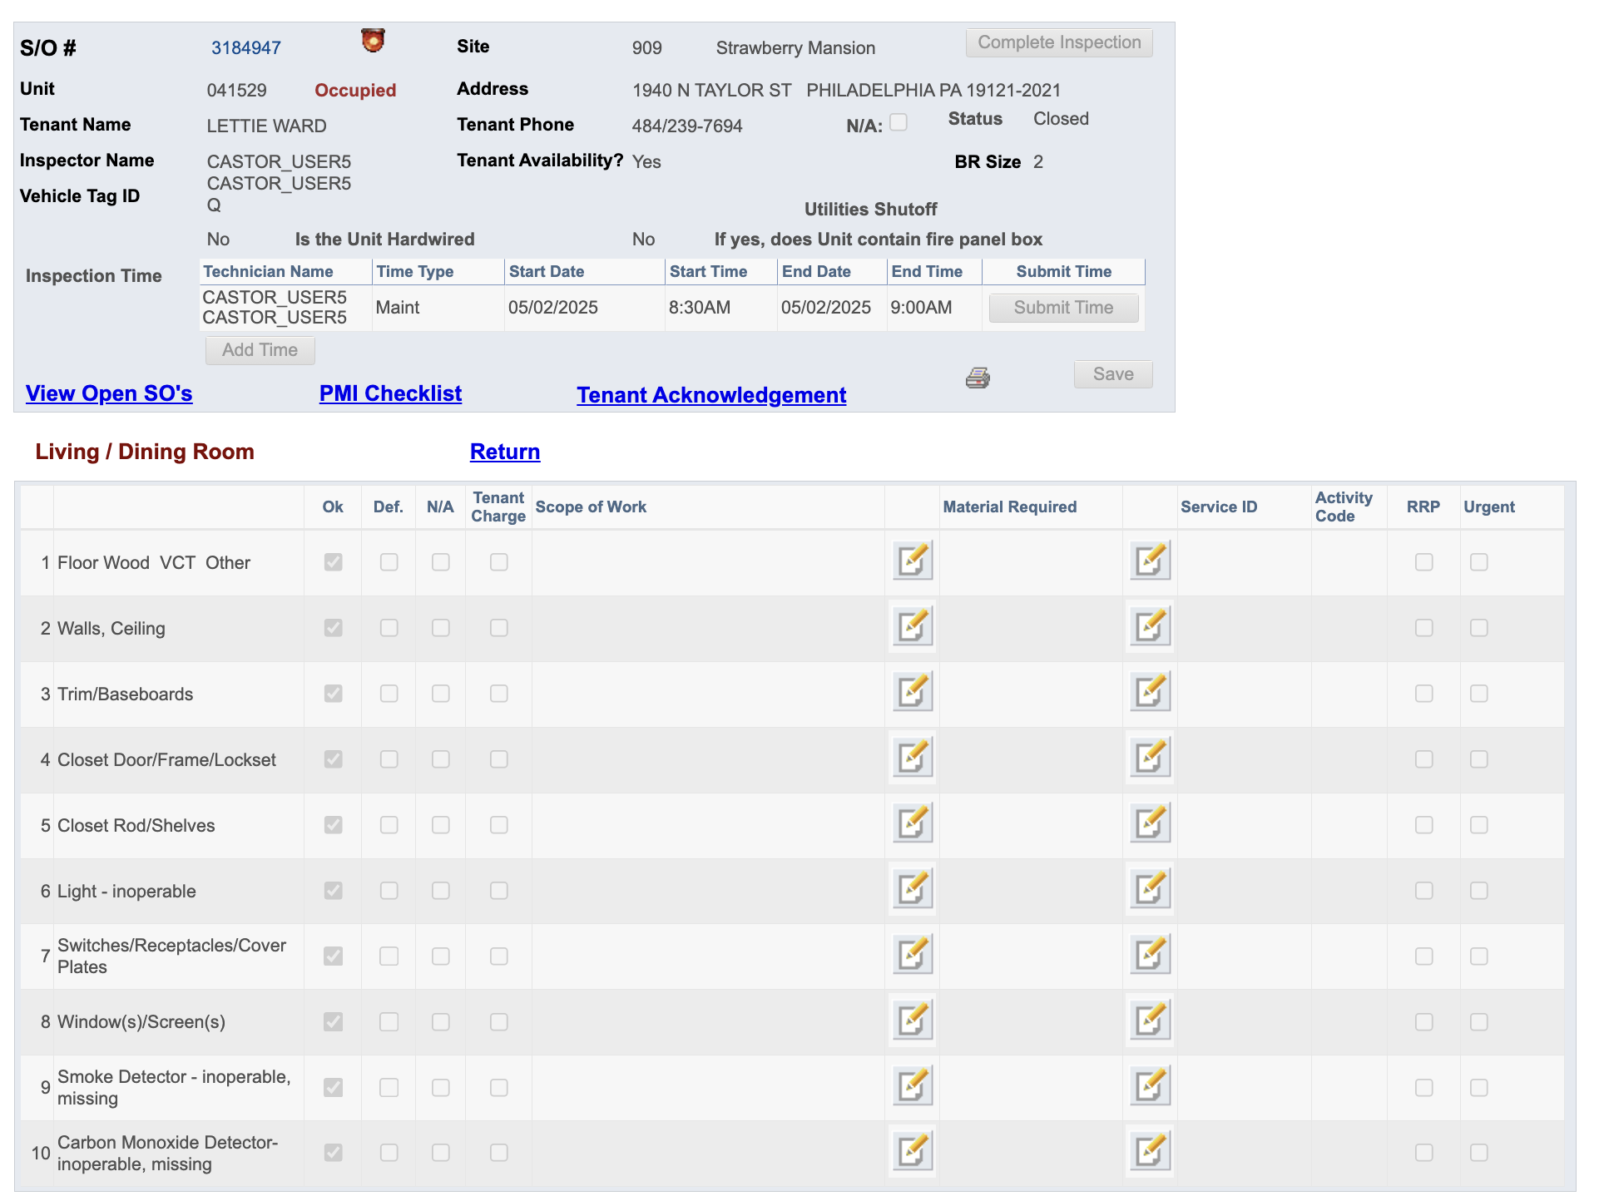

**Powder Room/Bathroom**

#### Coming back to the screen where it shows details for that **Inspection SO**

Now, if you click on Powder Room/Bathroom, this is what it shows:

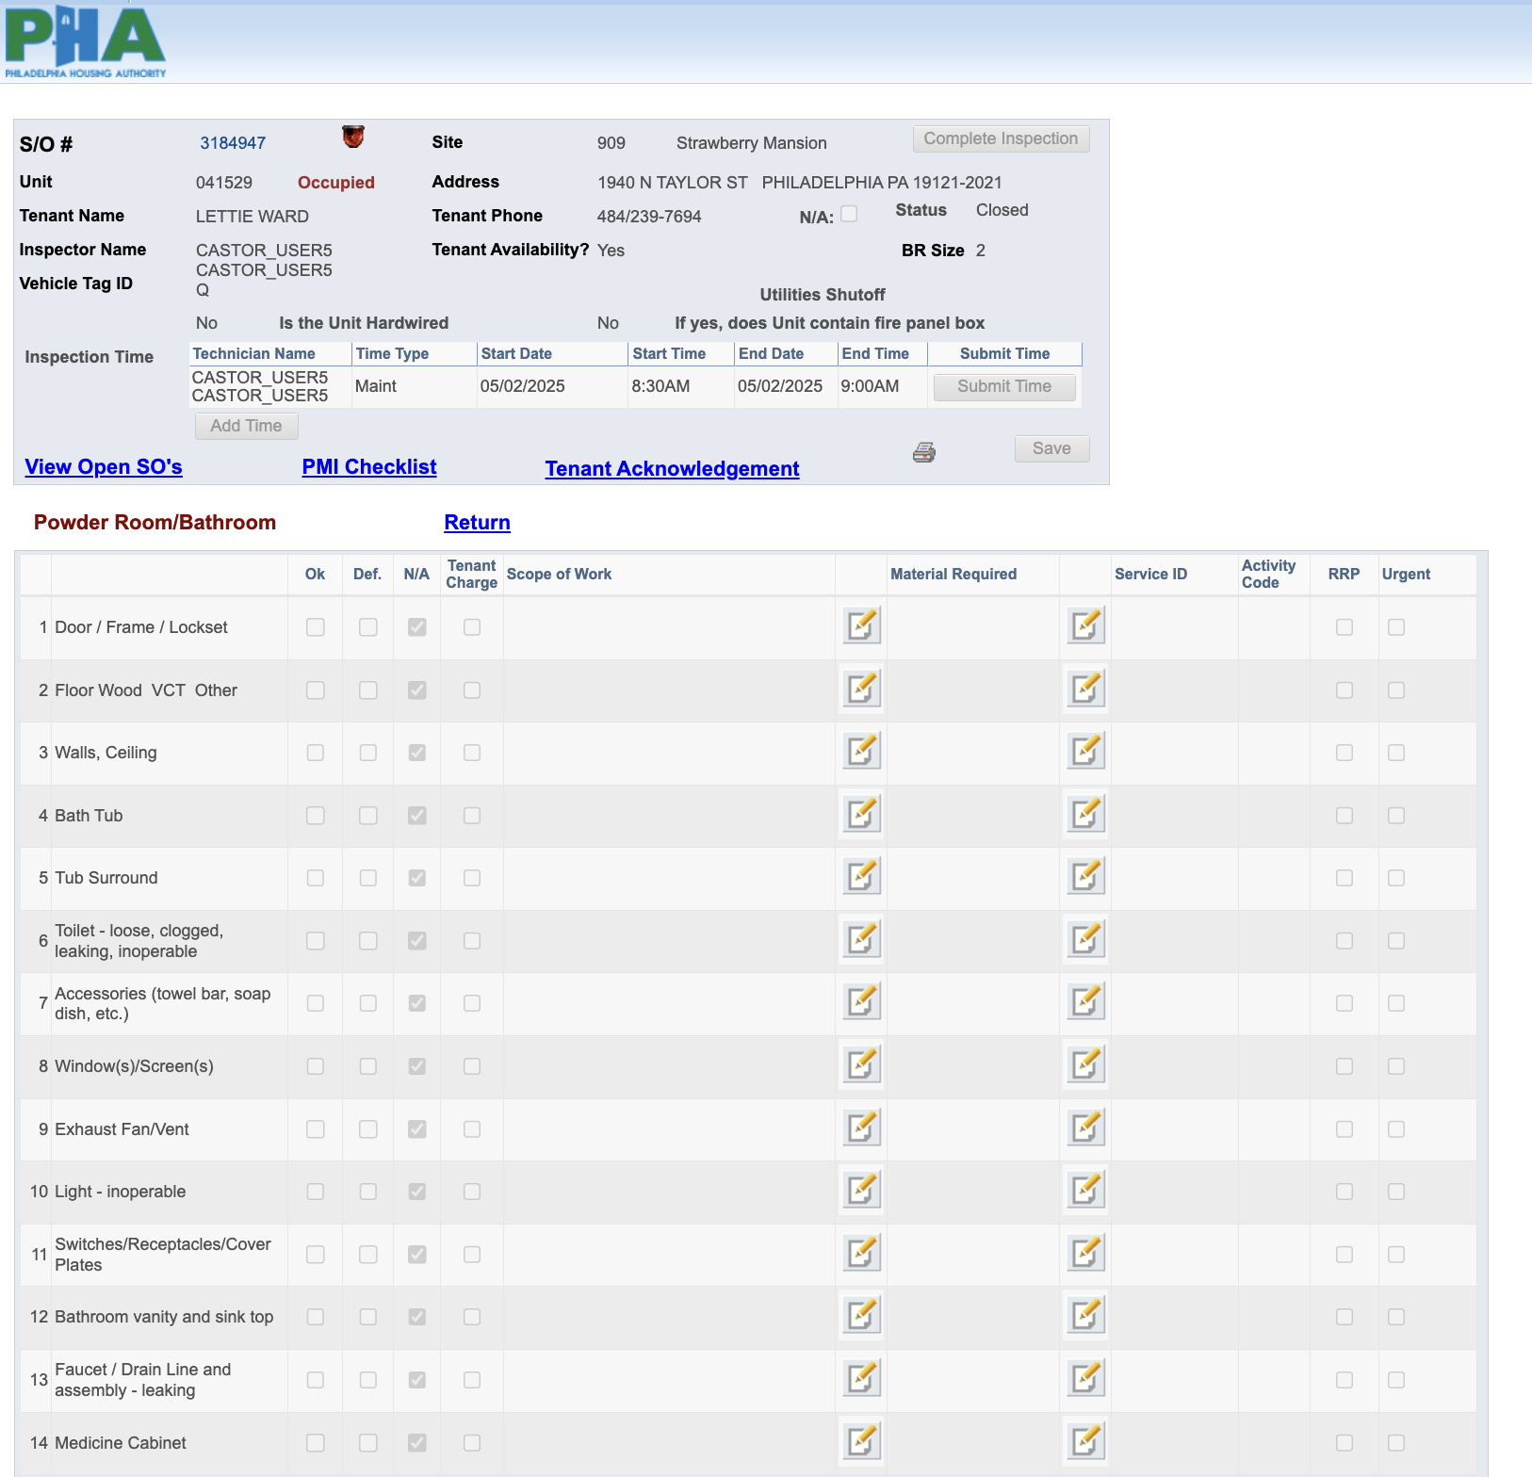

**Kitchen**

#### Coming back to the screen where it shows details for that **Inspection SO**

Now, if you click on Kitchen, this is what it shows:

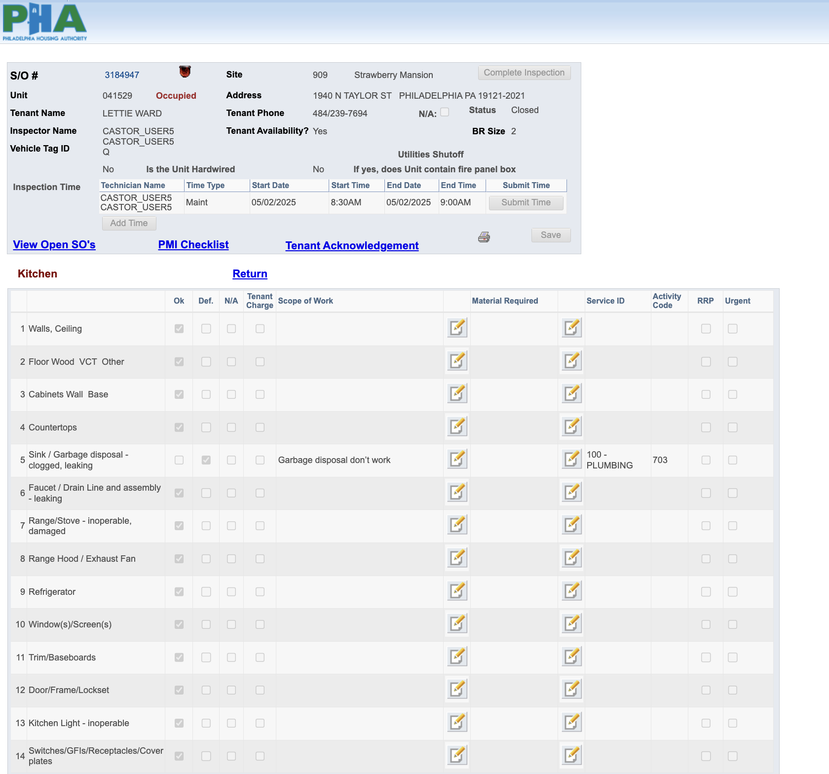

**Basement and Building Systems**

#### Coming back to the screen where it shows details for that **Inspection SO**

Now, if you click on Basement and Building Systems, this is what it shows:

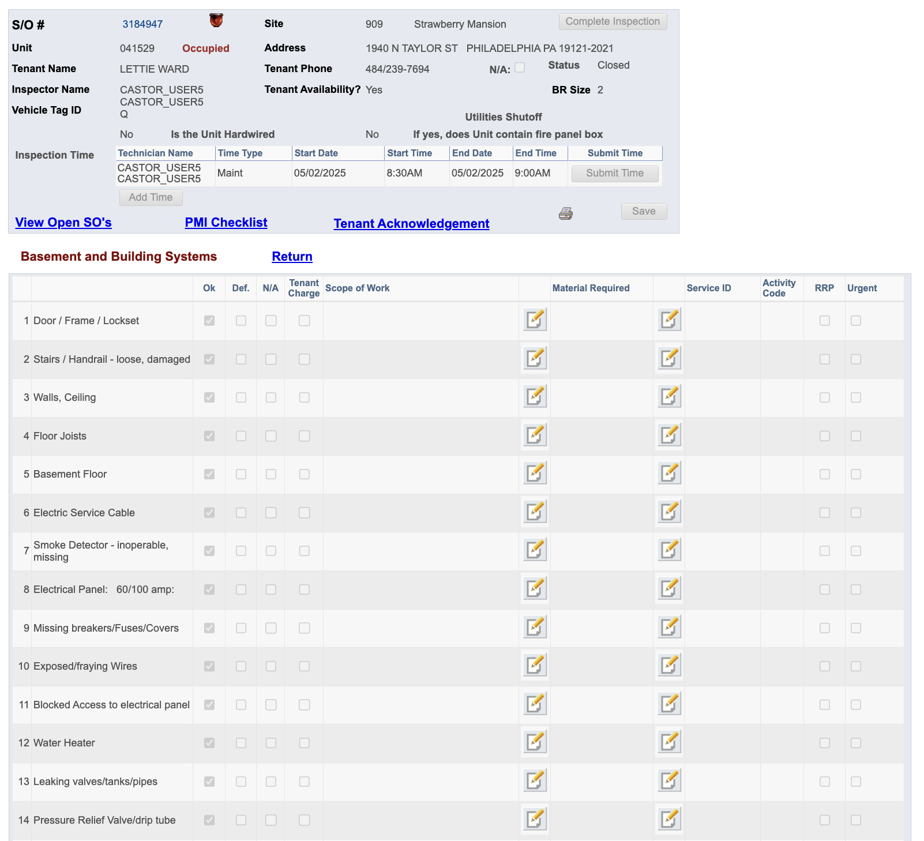

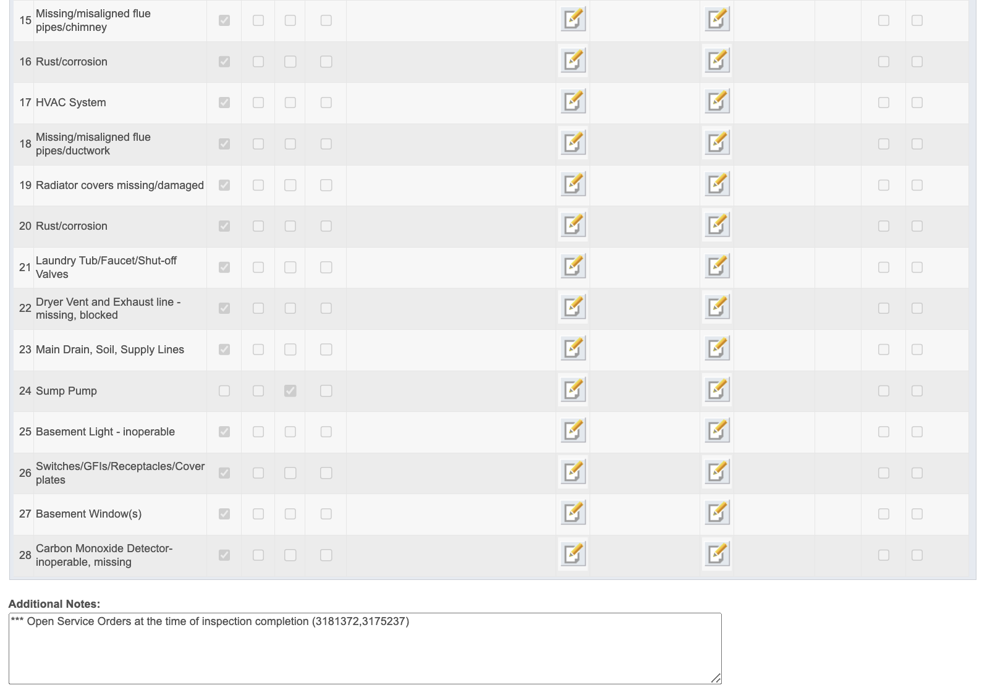

**Main Stair 1st to 2nd Floor & Hall**

#### Coming back to the screen where it shows details for that **Inspection SO**

Now, if you click on Main Stair 1st to 2nd Floor & Hall, this is what it shows:

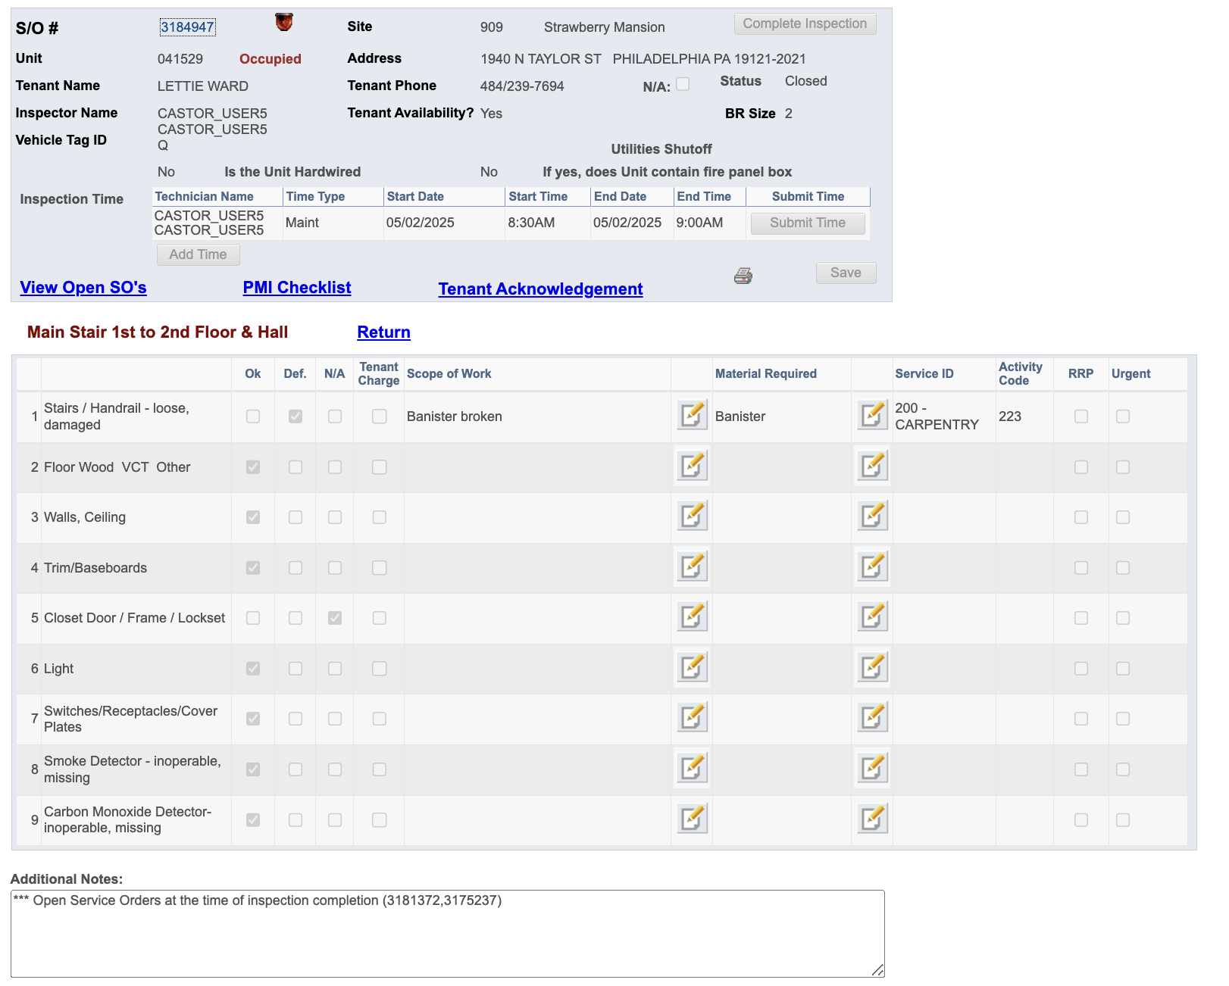

**2nd Floor Front Bedroom**

#### Coming back to the screen where it shows details for that **Inspection SO**

Now, if you click on 2nd Floor Front Bedroom, this is what it shows:

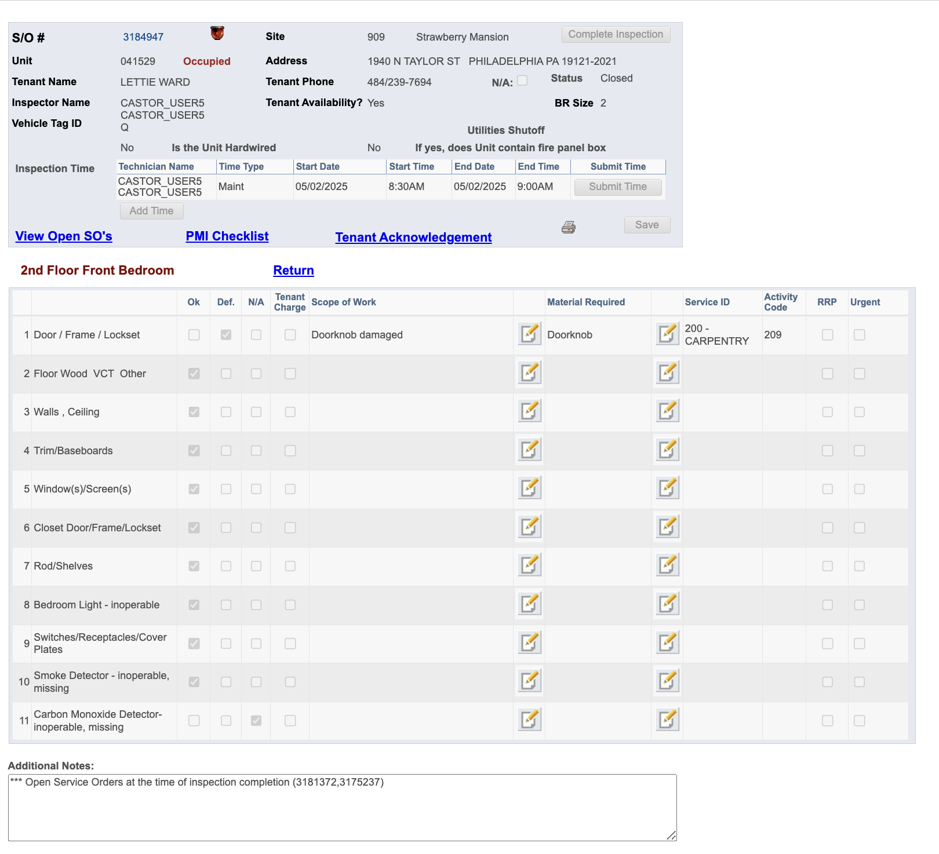

**2nd Floor Middle Bedroom**

#### Coming back to the screen where it shows details for that **Inspection SO**

Now, if you click on 2nd Floor Middle Bedroom, this is what it shows:

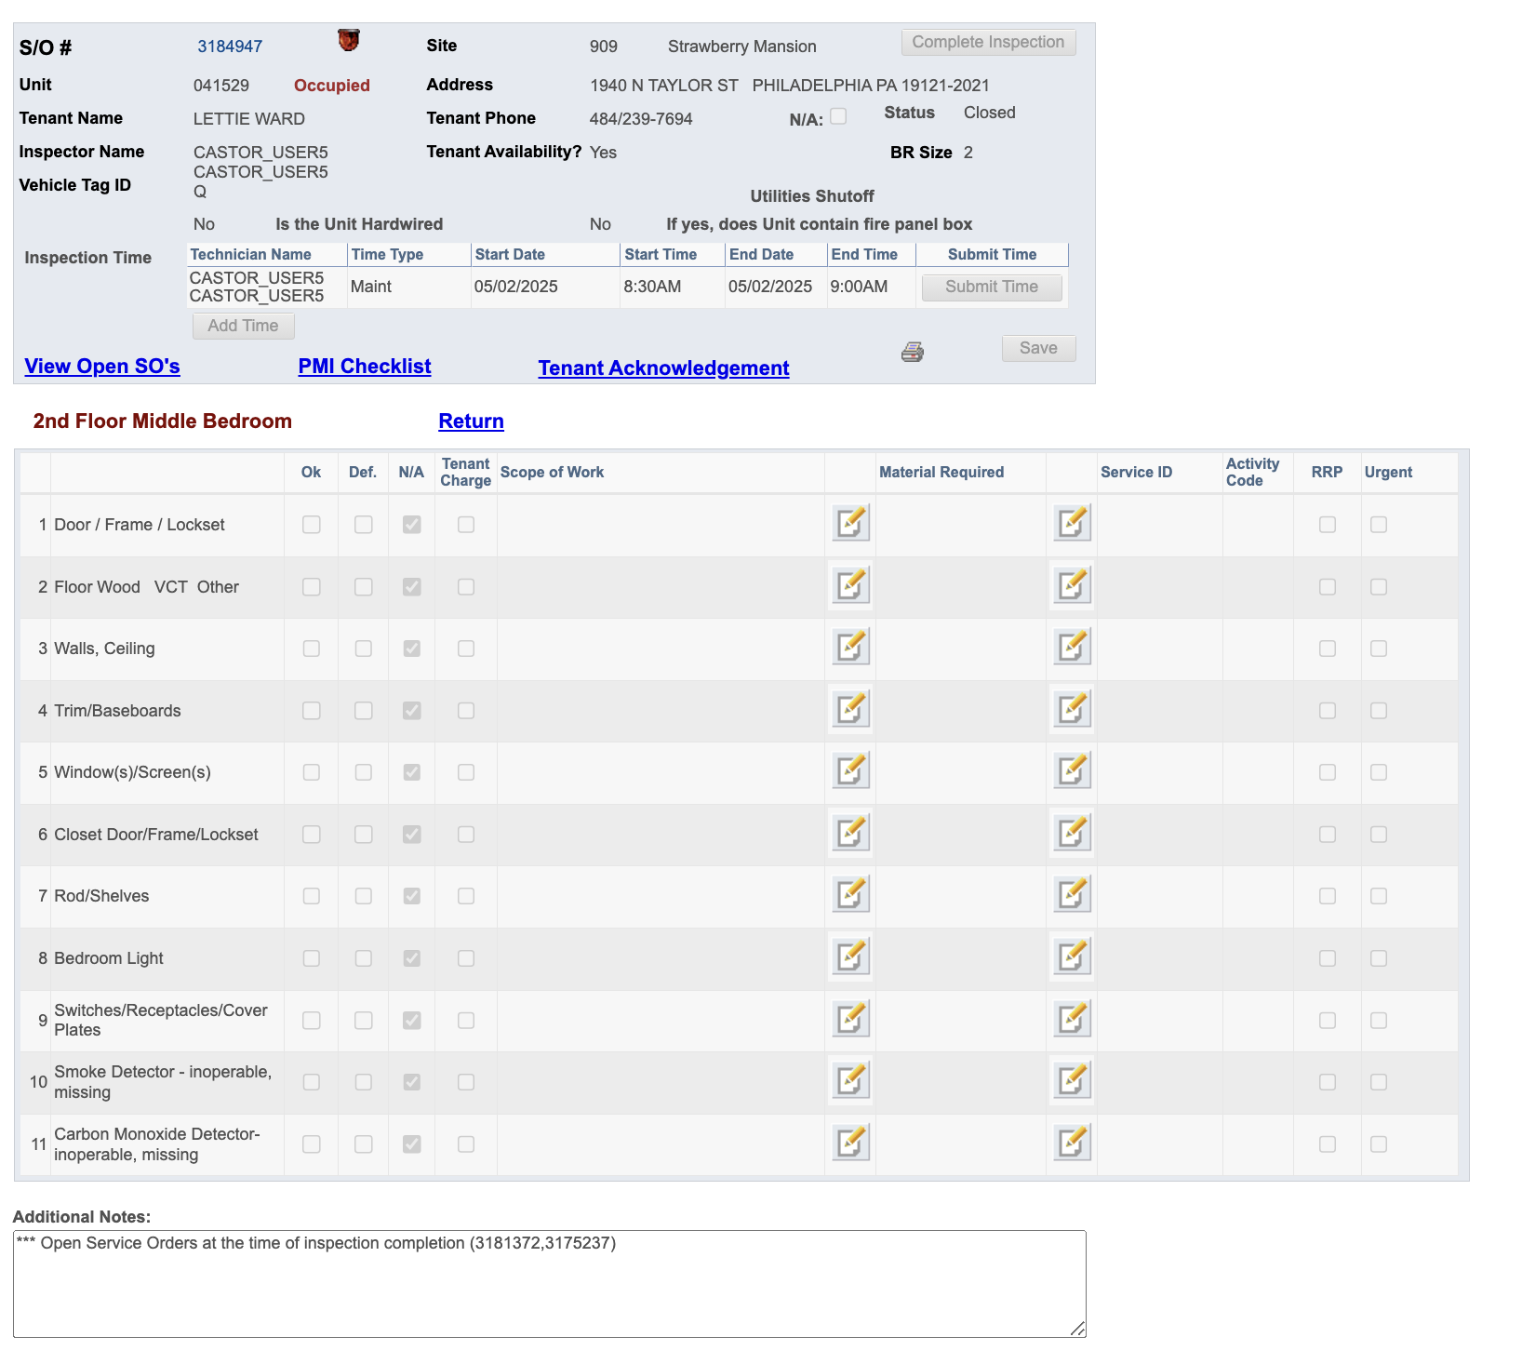

**2nd Floor Bathroom**

#### Coming back to the screen where it shows details for that **Inspection SO**

Now, if you click on 2nd Floor Bathroom, this is what it shows:

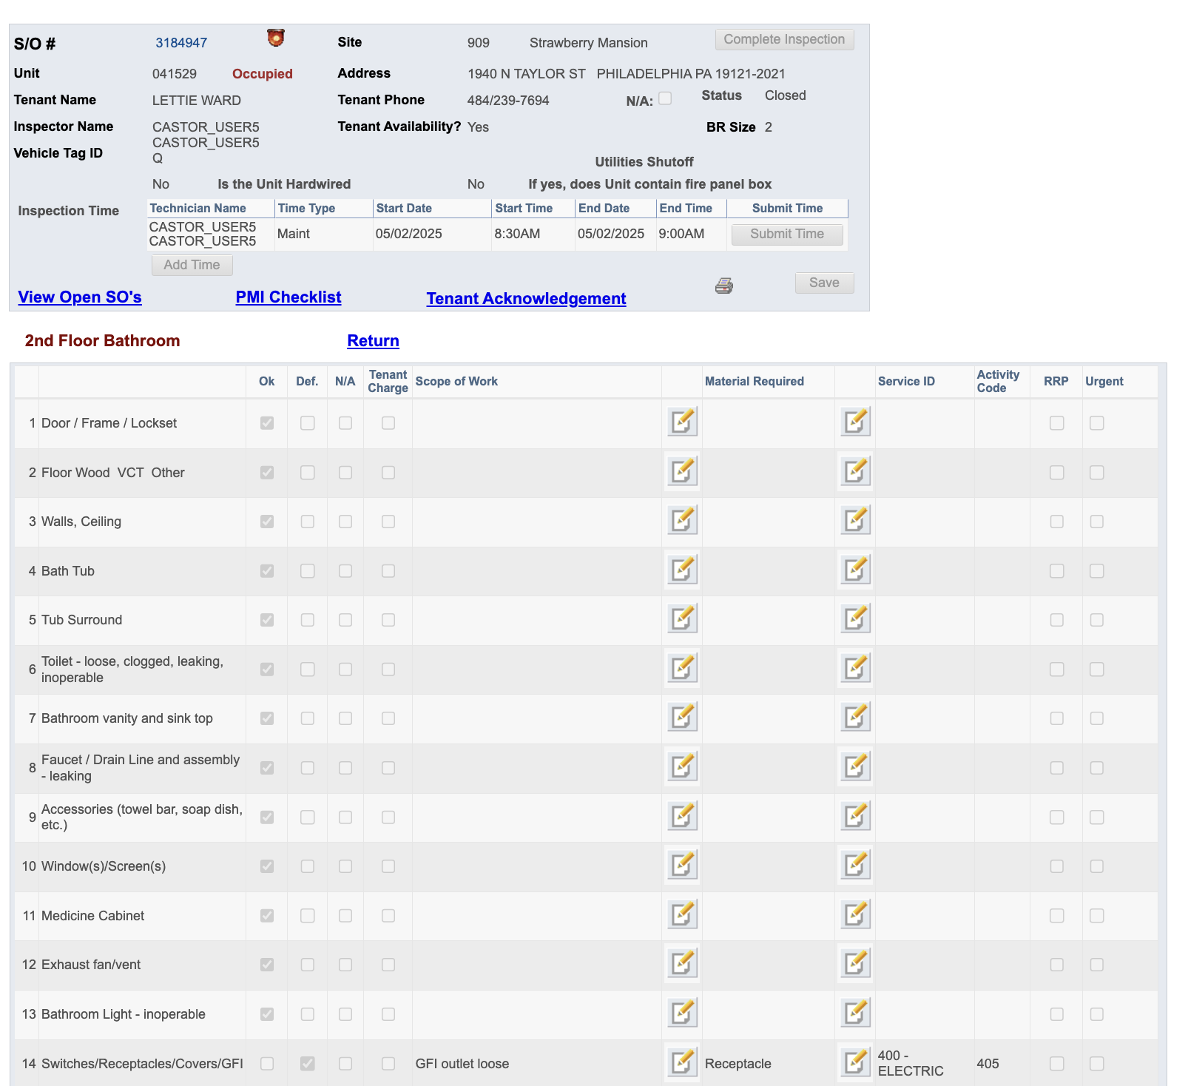

**2nd Floor Rear Bedroom**

#### Coming back to the screen where it shows details for that **Inspection SO**

Now, if you click on 2nd Floor Rear Bedroom, this is what it shows:

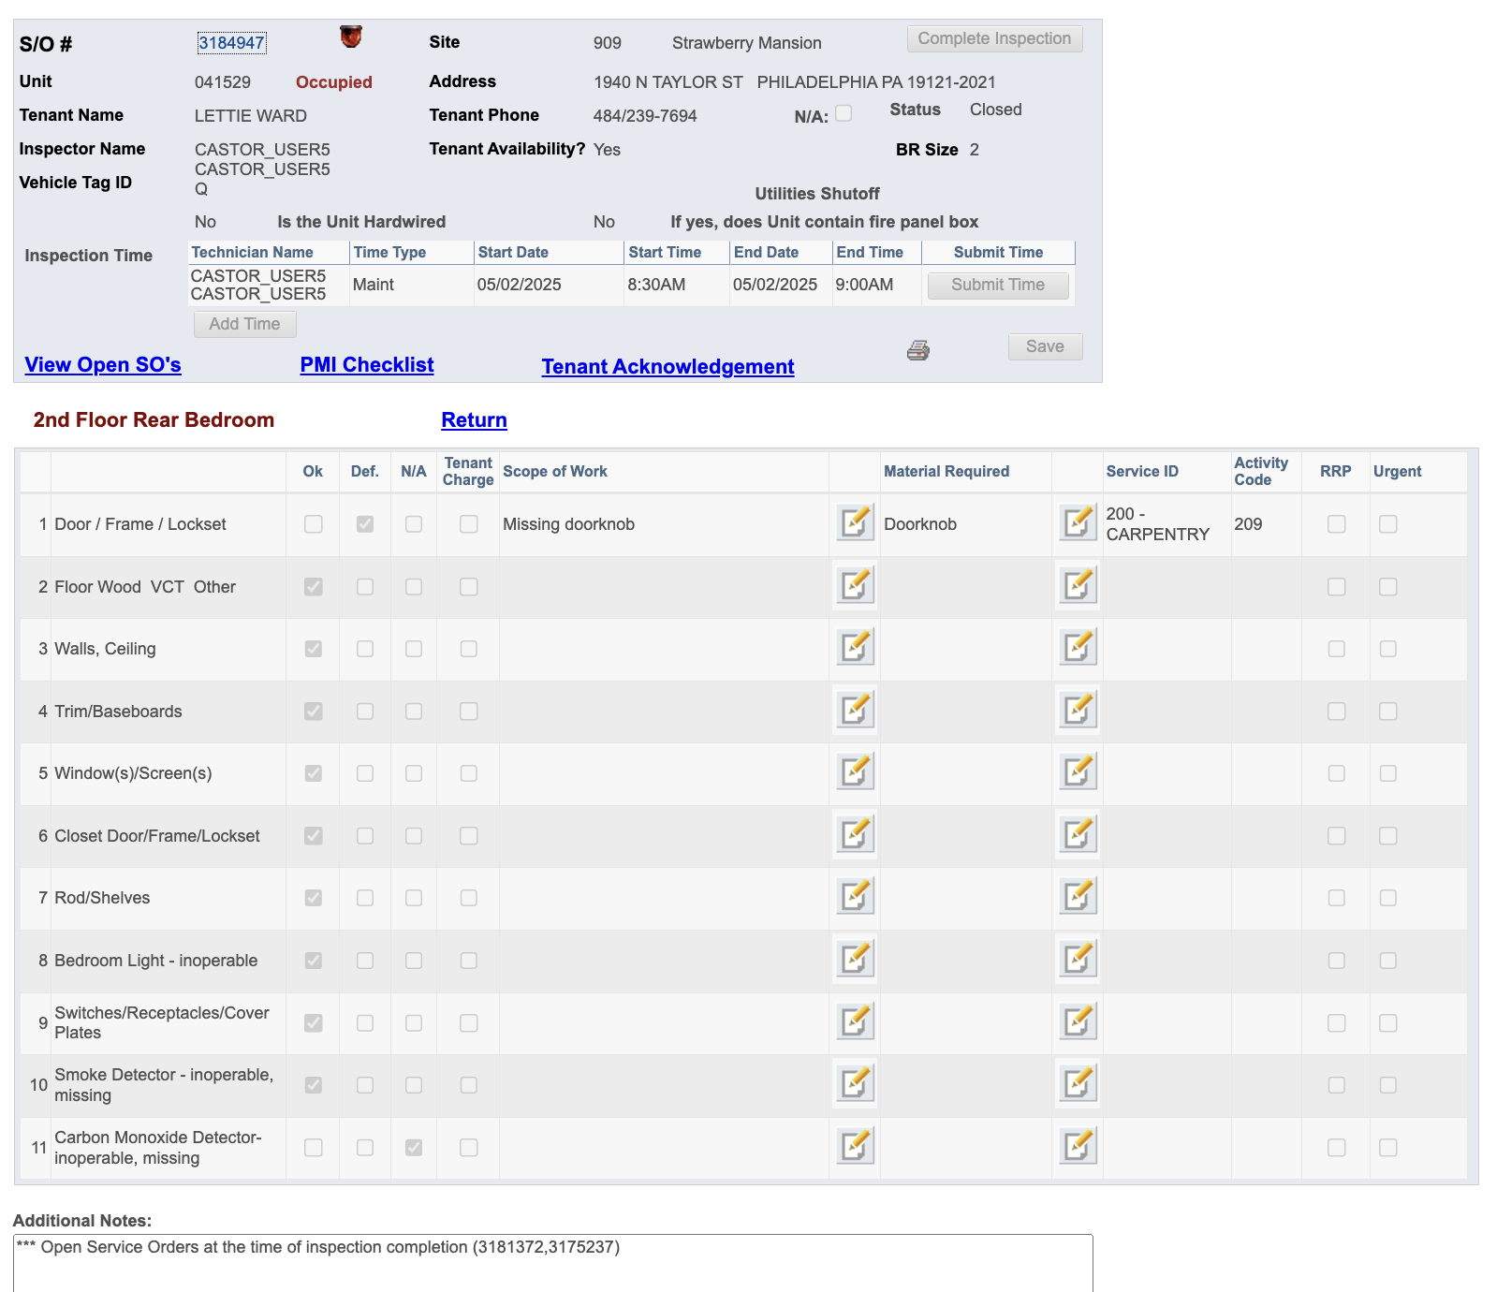

**Main Stair 2nd to 3rd Floor and Hall**

#### Coming back to the screen where it shows details for that **Inspection SO**

Now, if you click on Main Stair 2nd to 3rd Floor and Hall, this is what it shows:

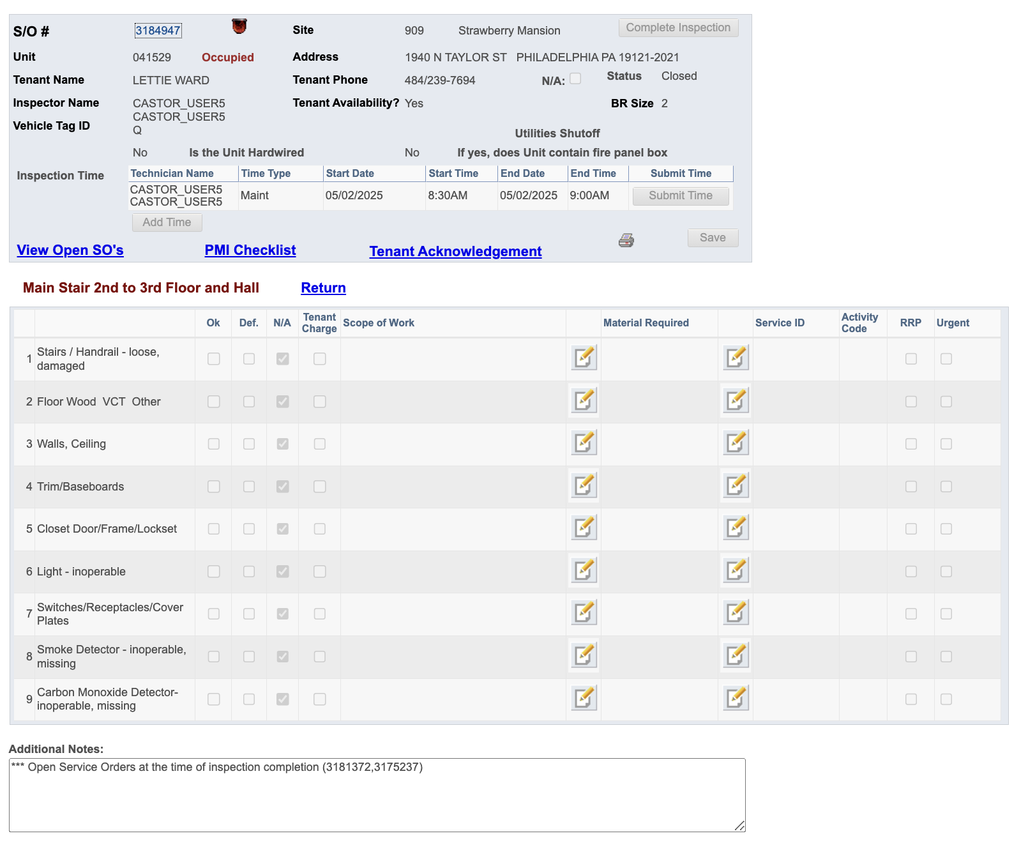

**3rd Floor Front Bedroom**

#### Coming back to the screen where it shows details for that **Inspection SO**

Now, if you click on 3rd Floor Front Bedroom, this is what it shows:

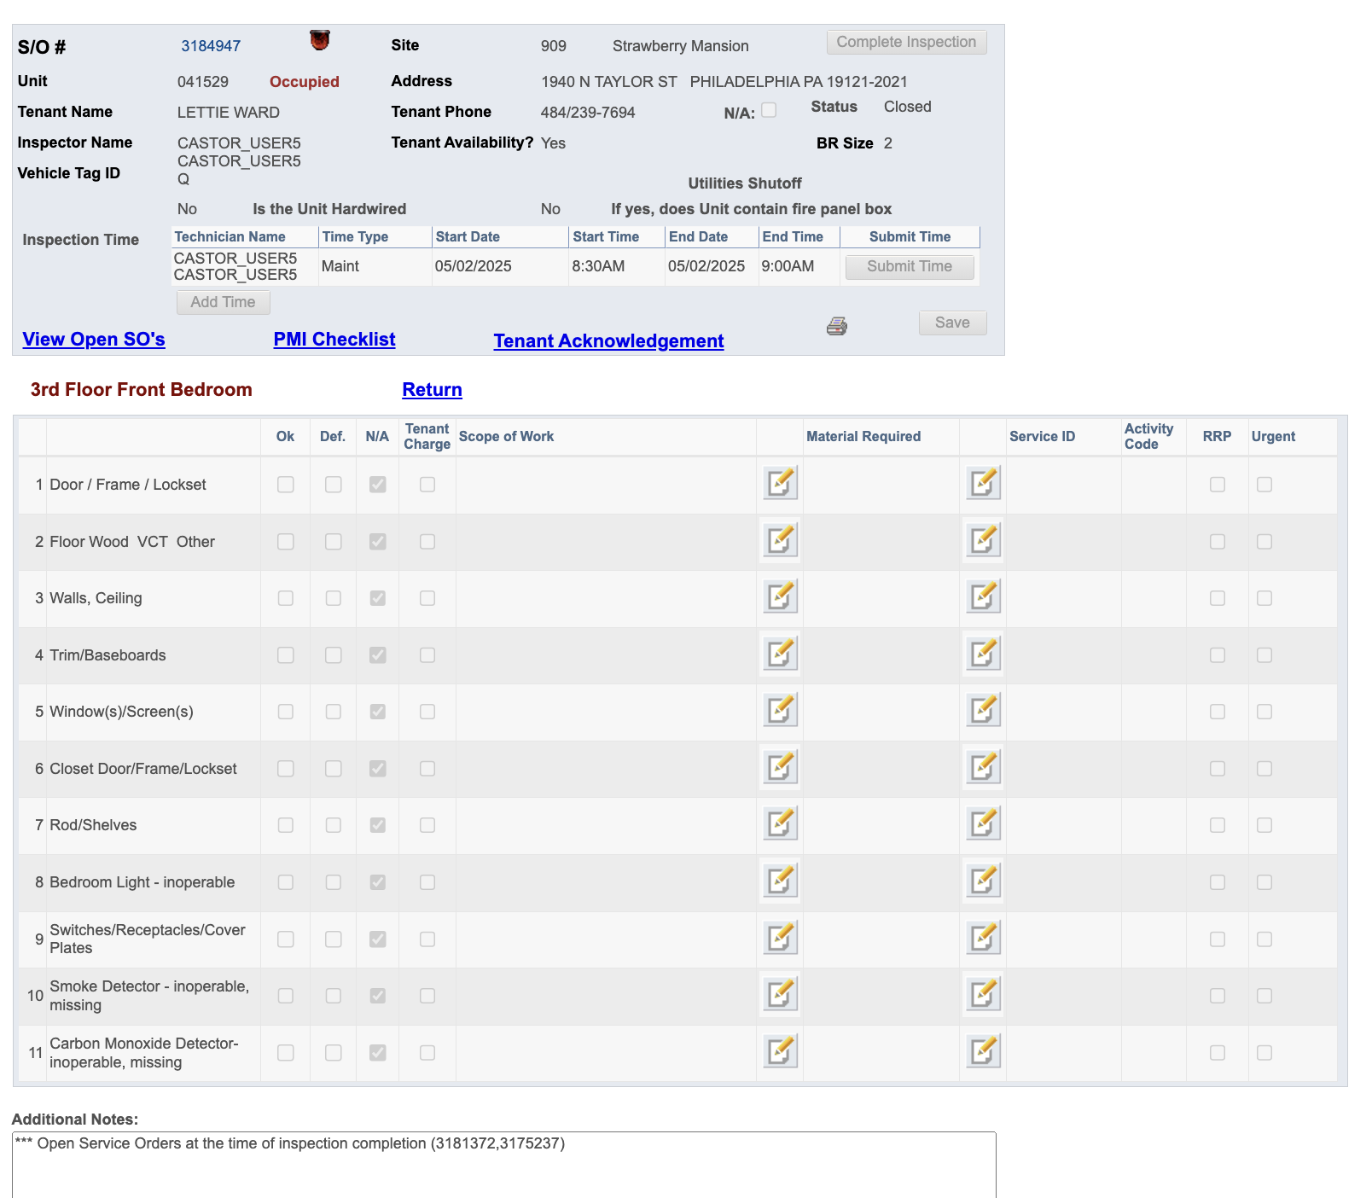

**3rd Floor Middle Bedroom**

#### Coming back to the screen where it shows details for that **Inspection SO**

Now, if you click on 3rd Floor Middle Bedroom, this is what it shows:

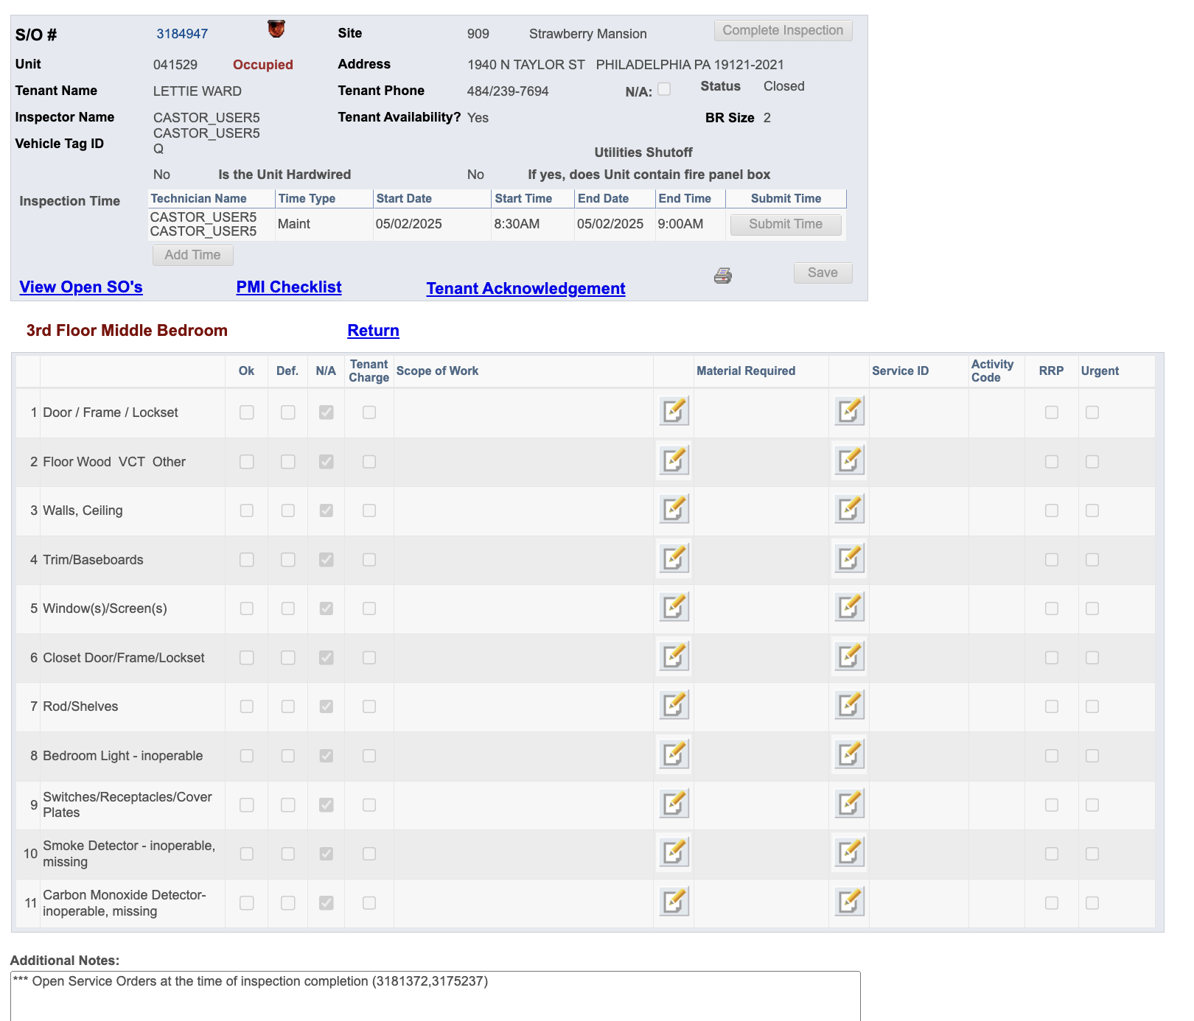

**3rd Floor Bathroom**

#### Coming back to the screen where it shows details for that **Inspection SO**

Now, if you click on 3rd Floor Bathroom, this is what it shows:

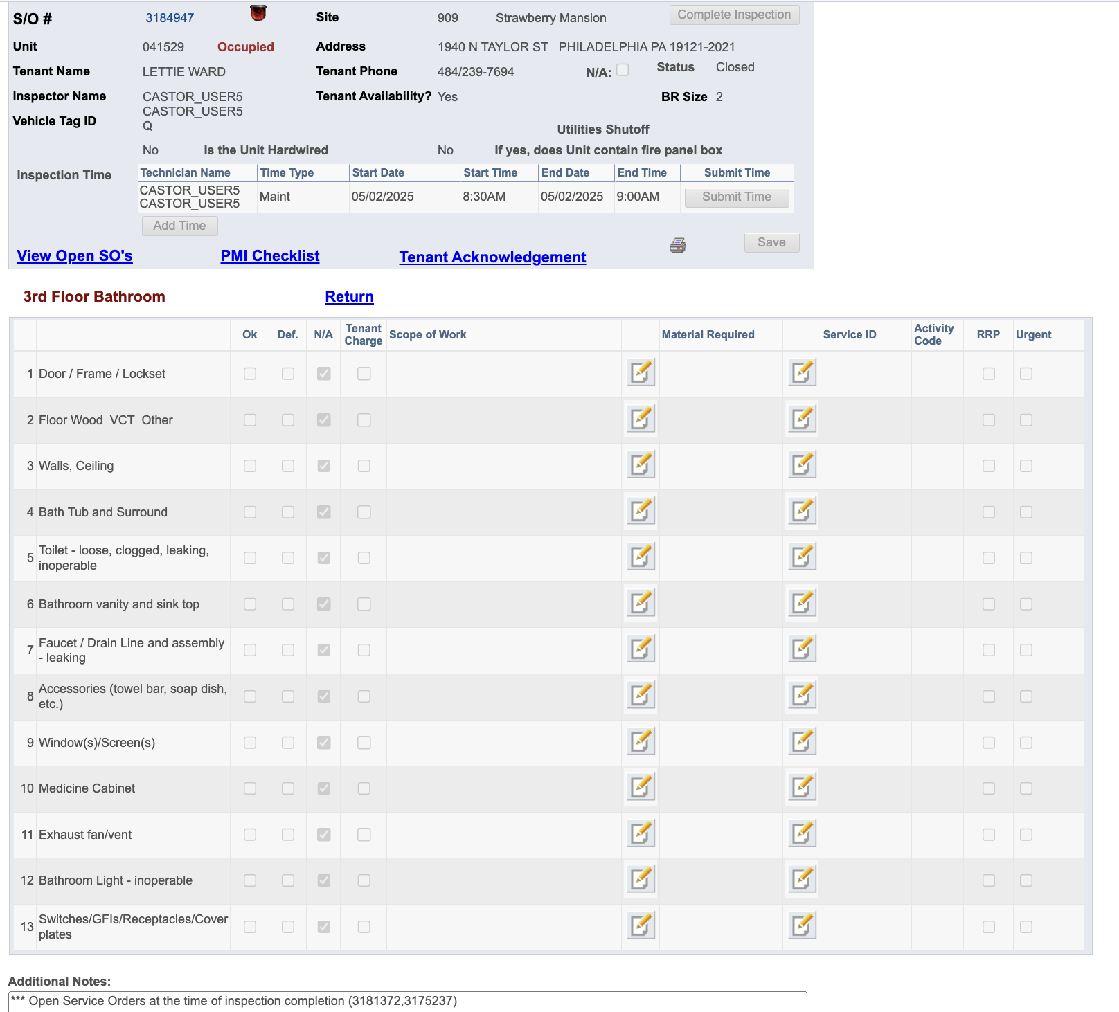

**3rd Floor Rear Bedroom**

#### Coming back to the screen where it shows details for that **Inspection SO**

Now, if you click on 3rd Floor Rear Bedroom, this is what it shows:

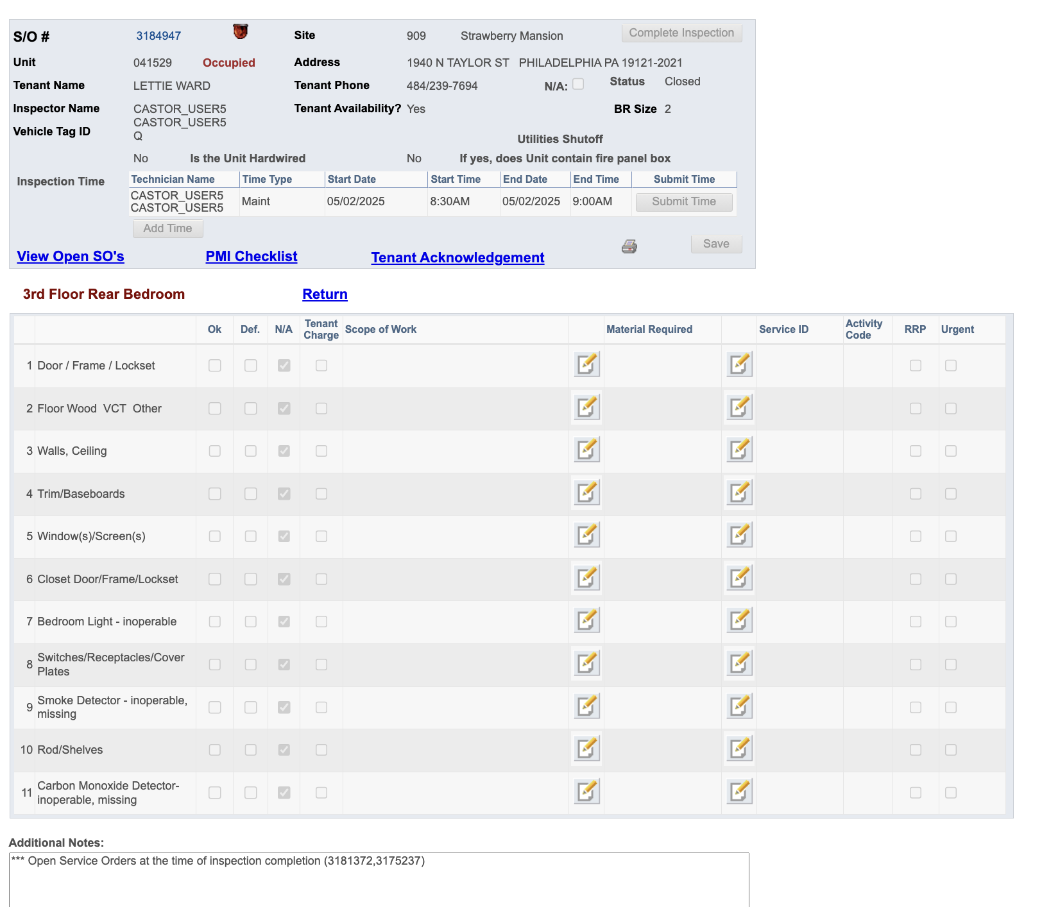

**EXIGENT HEALTH AND SAFETY**

#### Coming back to the screen where it shows details for that **Inspection SO**

Now, if you click on EHS, this is what it shows:

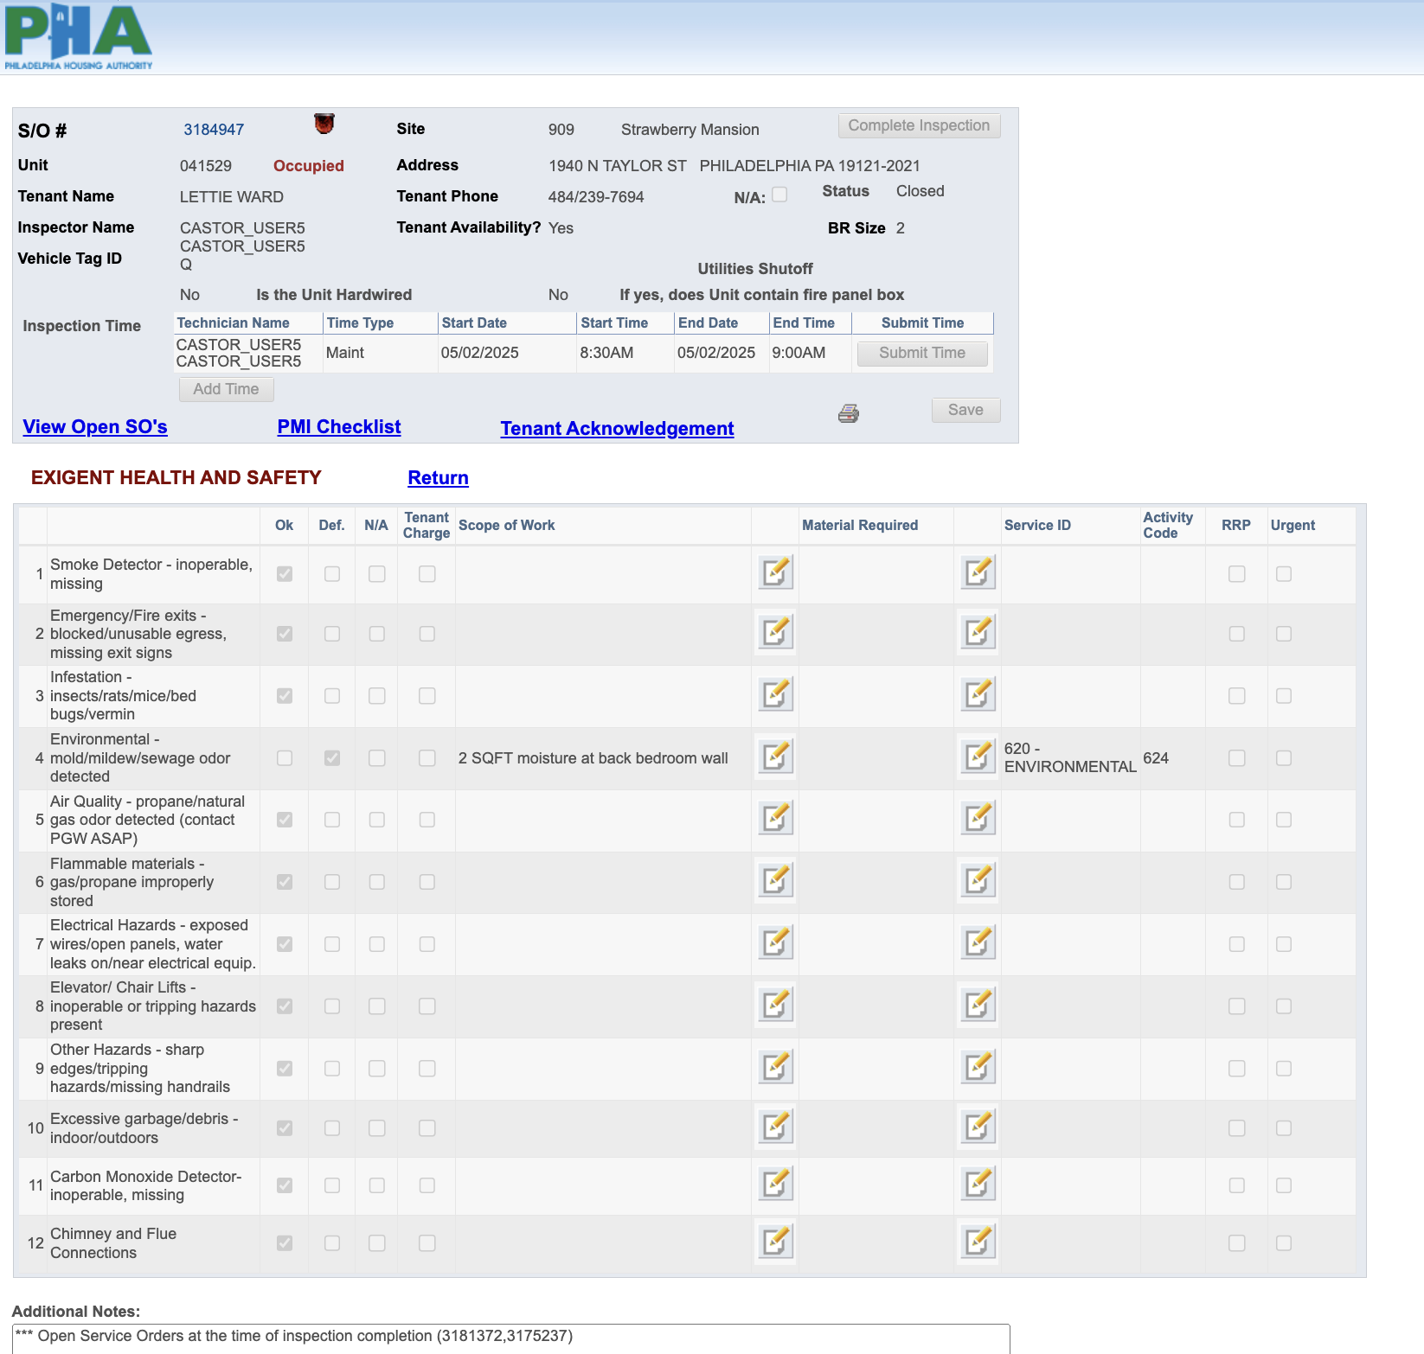

At the End when you come back to Inspection SO, it has these following:

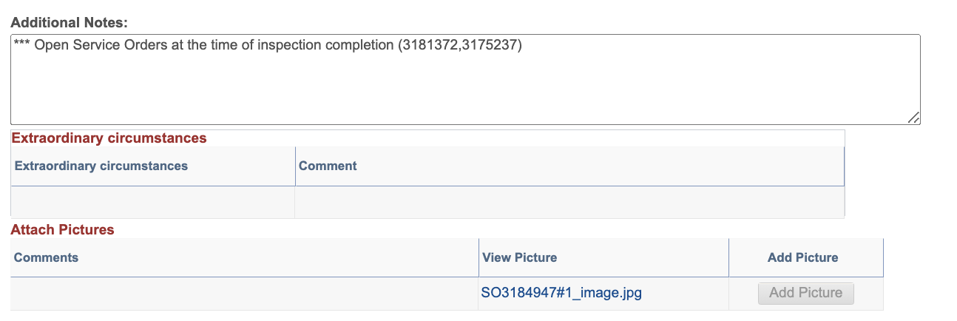

1. Attach Images ⇒ which allows inspectors to attach live images captured during the inspection
2. Extraordinary Circumstances